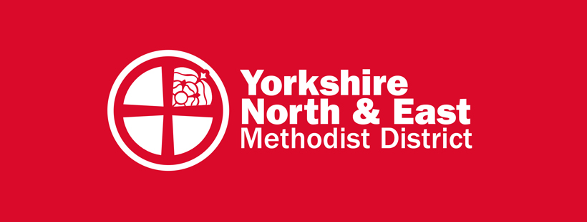
New Places for New People

Initial Ideas Form:
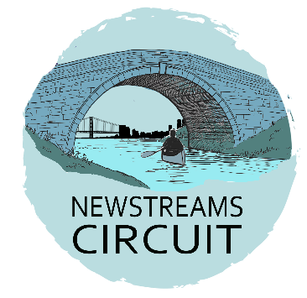
New Places for New People (NPNP) is a key component of the national Methodist Church’s God for All strategy. Our District has already launched the Kairos Movement, and established the New Streams circuit, with a small team with skills, experience and funds to support teams, churches and circuits in developing their own NPNPs, with the additional facility to act as both home and oversight for new developing NPNPs if desired. Several circuit projects have already launched, and others are in the planning phase. We would love to hear about your ideas for an NPNP, and in particular those being developed on the social and economic margins of society.

The purpose of this form is to document an initial idea for beginning a new faith community which can then be discussed with the District NPNP Team, who will support you as you develop your concept and launch your project.

––––––––––––––––––––––––––––––––––––––––––––––––––––––––––––––––––––––––––

Contact Name:

E-mail:

Telephone Number:

Role:

Minister in pastoral charge:

Circuit:

Background:
How did the idea for this new community come about?

What listening process has been pursued to arrive at these conclusions?

Context:
"The Church at the Margins strategic area of God For All is focused on equipping the Methodist Church to steward the majority of planting and pioneering resources with a faithful and preferential bias for people and communities experiencing marginalisation." Will your NPNP be a Church at the Margins initiative? If not, what demographic or target group are you seeking to connect with and why?

Oversight
Will your Church / Circuit have oversight of this project or might it best fit within the Kairos Movement, or under the oversight of the New Streams Circuit? Please give your reasons.
[If you wish to discuss the options here, please speak to Rev Andy Lindley, the NPNP Lead]

Team:
Who will be involved in making your NPNP happen?

Next Steps:
How will you get your NPNP up and running?

What would you like to see develop in the next six months?

Would a deeper or broader listening process help clarify the vision and gain new volunteers?

Do you foresee the need to experiment or run a short pilot project first?

Vision:
How do you imagine things might develop over the next six years?

Practicalities:
How best might the District NPNP team assist in getting this project started, or support what has already emerged?

Financial implications:
What, if any financial costs might be required to further develop and/or launch this initiative? If a grant was available how might it be used?

Please email this completed form to newstreams@yorkshirenemethodist.org
Thanks & God bless
The New Streams NPNP Team

