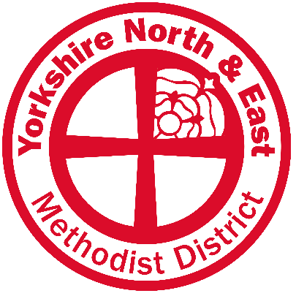
Lay Employee Database Record
To ensure that all information held on behalf of the Lay Employment Sub-Committee is correct (as required by Standing Order 438A) and we have the relevant permissions, please can all Lay Employees fill out this form and return to the District Office by post or email.
28 The Green, Acomb, York, YO26 5LR
admin@yorkshirenemethodist.org
If you have any questions about this, please do not hesitate to contact the District Administrator, Naomi Prince, on 07539 027151
Full Name:

Job Title:

Work Email (or other appropriate email)*:

Number of hours worked per week:

Name of the employing body:

Place of work address:

Line Manager’s name:

Line Manager's email address:

*an email address is requested to enable the District Office to make direct contact with the lay employee and will be used only by the District Office in relation to information or events that might be of interest to Lay Employees of the District. Please see below regarding consent around inclusion on other related email lists.
All information will be held on the District Database until advised otherwise. For full details of how Yorkshire North and East uses your information, please refer to our Privacy Policy which is available on our website here https://www.yorkshirenemethodist.org/privacy-policy/

Consent
As a Lay Employee of the Methodist Church the District has three other email lists that might be of interest to you. This contact information will be held centrally by the District Office and shared as appropriate to the necessary parties.
Wellbeing communications
As Wellbeing Officer Tara is available to chat with or meet up with and any Wellbeing mailings will be occasional and relevant to improving or nurturing your own wellbeing or relating to wellbeing across the District/Region.
You can contact her separately on wellbeing@yorkshirenemethodist.org
Community of Practice
By agreeing to communications regarding the Lay Employee Community of Practice you will receive emails regarding monthly coffee and wellbeing drop-in sessions, training opportunities relevant to your area of work as well as half termly newsletters that offer information regarding other activities and events happening around the District and Region. We make every effort to keep these emails to a minimum and to only send information relevant to your role.
Spirituality mailings
Spirituality mailings: Tara is co-ordinating a Spirituality mailing to advertise quiet days, retreats, silent space, quiet garden, contemplation etc. Nurturing our own journeying with God is important to feed our own faith. Please sign up if you are interested in this type of event/zoom.
I give consent for my name and email to be used for the following email lists for the next Methodist Year (September 2022 - August 2023)
(Please tick as appropriate)
Wellbeing Communications
Community of Practice
Spirituality Mailings
None of the above

Signed (print name) ____________________________
Signature_______________________
Date ___________________
(This consent will be renewed on a yearly basis)

