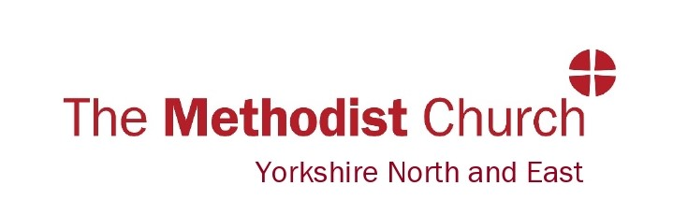
SAFEGUARDING GUIDELINES
CHURCH SOCIAL MEDIA POLICY

Name of church/circuit
Date policy was agreed by the Church Council | [Date] | Date policy will be reviewed | [Date of next review]
Signed on behalf of Church Council | [Signature]  [Role]

Statement of Safeguarding Principles and Commitments to Safeguarding
It is the Methodist Church’s intention to value every human being as part of God’s creation and the whole people of God. At the heart of the Methodist community is a deep sense of the place of welcome, hospitality and openness, which demonstrates the nature of God’s grace and love for all.

Our online spaces are an extension of the church community. In both online and physical spaces, we are called be places where the transformational love of God is embodied and life in all its fullness is a gift which is offered to all people. Safeguarding is about the action the Church takes to promote a safer culture both in physical and online spaces. This means we will:
- promote the welfare of children, young people, and adults
- work to prevent abuse from occurring
- seek to protect and respond well to those that have been abused.

We are committed to:
- the care and nurture of, and respectful pastoral ministry with, all children, young people, and adults
- safeguarding and protecting all children, young people, and adults when they are vulnerable
- establishing safe, caring online communities and spaces, which provide a loving environment where there is informed vigilance as to the dangers of abuse.

The Methodist Church is committed to the safeguarding and protection of all who use online spaces associated or affiliated with the Methodist Church. We seek to protect vulnerable groups who can be more at risk from harm and abuse.

The Methodist Church recognises that most forms of abuse can take also take place online as well as in physical spaces, therefore it is paramount to extend safeguarding into online places used for worship, communication, or other activities.

.............................. Methodist Church will commit to:

- RESPOND without delay to any allegation or cause for concern that a child or vulnerable adult may have been harmed or may suffer harm, whether in the church, in an online space, or in another context. It commits itself to challenge the abuse of power of anyone in a position of trust.
- IMPLEMENT the Methodist Church Safeguarding Policy, Social Media Policy, government legislation and guidance about safe practice.
- PROVIDE support, advice, and training for lay and ordained people to ensure that people are clear and confident about their roles and responsibilities in safeguarding and promoting the welfare of children and adults who may be vulnerable.
- AFFIRM and give thanks for those who work with children and vulnerable adults and acknowledge the shared responsibility of all of us for safeguarding children and vulnerable adults who use our online spaces.
How are Safeguarding Commitments will be Achieved
- As legal responsibility for safeguarding lies with trustees of the church, the Church Council will approve any online spaces associated with the Methodist Church e.g., WhatsApp Groups, Facebook page etc.
- We will carefully recruit those who have responsibility for online spaces associated with the church. Those who have specific roles in online spaces with children, young people or vulnerable adults will have appropriate DBS checks and training [please see Social Media Access Forms created by the Yorkshire North and East Methodist District].
- We will respond without delay to any safeguarding concerns that emerge online which suggests that a child, young person, or adult may be at risk of harm. Any issues will be reported to the Church/Circuit/District safeguarding officer and Minister/Superintendent where appropriate. An appropriate record of concerns will be made.
- We will seek to challenge any inappropriate behaviour displayed online by those who are in membership and roles within the Methodist Church. Any concerns or issues should be reported to the Minister/Superintendent and safeguarding officers where appropriate.
- Where individuals are considered a risk towards others; we will work with the District Safeguarding Officer to ensure that there are sufficient safeguards in place that will enable an individual to engage in online spaces.
- We will do our upmost to ensure that we protect the privacy and personal details of others, ensuring that our online spaces have appropriate and adequate security settings [Further guidance can be obtained in the Digital Resources Hub created by the Yorkshire North and East Methodist District or through contacting our Digital Communications Enabler].
- We will promote and encourage those responsible for online spaces to follow good practice guidance and codes of conduct when working online [please refer to Social Media Code of Conduct created by the Yorkshire North and East District].
- We will follow good safeguarding practice when working with children, young people and vulnerable adults in online spaces as outlined in the Methodist Church Policies, Procedures and Guidance.
- Ensure that the Church Safeguarding Policy and Social Media Policy is updated, reviewed annually and is available online at request.
- We will regularly review the safeguarding of our online spaces.
- We will make all users of our online spaces aware of any rules, boundaries, or guidelines for appropriate interaction in an online space.
This Social Media Policy should be read in conjunction with the Church/Circuit Safeguarding Policy, Methodist Policy Procedures and Guidance, as well as the Digital Safeguarding Best Practice Reference Document developed by the Yorkshire North and East Methodist District and the Methodist Church.

