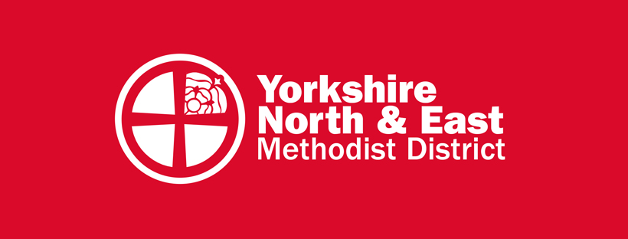
New Places for New People

Initial Ideas Form:

New Places for New People is a key component of the national Methodist Church’s God for All strategy. Over the next few years, each district across the connexion will be challenged to start several new faith communities. As this initiative develops, a special emphasis will be given to supporting churches on the social and economic margins of society.

The purpose of this form is to document an initial idea for beginning a new faith community which can then be discussed with the District NPNP Team, who will support you as you develop your concept and launch your project.

––––––––––––––––––––––––––––––––––––––––––––––––––––––––––––––––––––––––––

Contact Name:

E-mail:

Telephone Number:

Role:

Minister in pastoral charge:

Circuit:

Background:
How did the idea for this new community come about?

Context:
"The Church at the Margins strategic area of God For All is focused on equipping the Methodist Church to steward the majority of planting and pioneering resources with a faithful and preferential bias for people and communities experiencing marginalisation." Will your NPNP be a Church at the Margins initiative? If not, what demographic or target group are you seeking to connect with and why?

Oversight
Will your Church / Circuit have oversight of this project or might it best fit within the Kairos Movement? Please give your reasons.

Team:
Who will be involved in making your NPNP happen?

Next Steps:
How will you get your NPNP up and running? What would you like to see develop in the next six months?

Vision:
How do you imagine things might develop over the next six years?

Practicalities:
How best might the District NPNP team assist in getting this project started, or support what has already emerged?

Financial implications:
What, if any financial costs might be required to launch this initiative? If a grant was available how might it be used?

Please email this completed form to admin@yorkshirenemethodist.org
Thanks & God bless
The District NPNP Team

