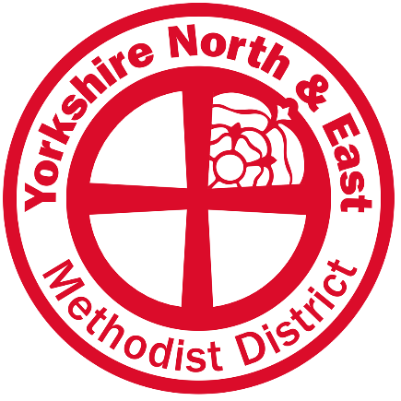

Representative Session of the Synod:

"Relight our Fire”

Dear Friends April 2022

We look forward to welcoming you to the Representative Session of the Yorkshire North and East District Synod on Saturday, 7th May 2022. This will be an in-person Synod, held at York Manor Academy. (York Manor Academy, Millfield Lane, Nether Poppleton, YORK, YO26 6PA). As previously agreed, we intend to have a pattern of one in-person synod and one online synod each year, and anticipate, therefore, that the September 22 synod will be online.
We want to ensure that everyone feels as comfortable as possible and there will be plenty of space with some tables set aside for any who wish to social distance. Mask-wearing will be for individual discretion, but we encourage everyone to be sensitive and careful. A live stream of the main session of synod will be provided for visitors who are interested in observing synod, although visitors are also very welcome to attend in person but should please advise the District Office of their attendance in advance. (admin@yorkshirenemethodist.org)
The day will include the usual Synod business plus worship, workshops and talks by Trey Hall, Jill Marsh, and Rachel Lampard – please see the attached draft agenda. We are seeking to create a sacred and safe place in which we will explore our Synod theme.
We will begin at 9:30am and finish at 3:30pm, with breaks for refreshments and lunch. Please bring your own mug for drinks, to cut down on waste, and please bring lunch and any snacks that you might need through the day. Also, if you are attending in person and would require the use of the hearing loop system, please could you inform the district office in advance.
Synod papers will be available on the District website at: www.yorkshirenemethodist.org/district/synods or can be requested to be emailed directly, or printed and posted, by contacting the District Office at admin@yorkshirenemethodist.org or by phoning/texting 07809 431871
In calling you to the Synod, it is also our responsibility to remind you, as required by Conference, that “every presbyter and every deacon who is not a supernumerary, and every presbyteral and diaconal probationer, unless, in any case, excused by dispensation of the Chair, is required to attend the Synod of which he or she is a member and to remain throughout its sessions. A dispensation of absence is to be given only on compelling grounds.” This also applies to Recognised and Regarded ministers.
Supernumerary Ministers and Ministers Authorised to Serve are welcome to attend the Representative Synod, but do not need a dispensation of absence if unable to attend. Lay members of Synod who are unable to attend are asked to notify the Synod Secretary via the District Office and to let their Circuit-meeting elected substitute have their Synod Papers.
We look forward to worshipping and reflecting together in these challenging times.
With best wishes,

Leslie Newton Emma Crippen
Chair of District Synod Secretary
AGENDA

‘Relight our Fire‘

9.00am Registration and coffee

9.30am Welcome, introductions and opening worship

9.40am Opening business:

• Letters of greeting
• Dispensations and apologies
• Election of scrutineers

9.50am Church closures:
Permission to cease worship for: New Earswick, Stamford Bridge, Barmby Moor, Finghall, Dunnington, South Cliff, Thorngumbald and Bolton.

10.05am Other Synod Business

10.25am Chair’s Re-invitation

10:40am ‘Relight our Fire’ Introduction – Leslie Newton

11:00am Refreshment Break

11:20am Talk 1: “For All” Revd Jill Marsh, Inclusive Church Officer
- Followed by 10 minutes for conversation.

11:40 am Talk 2: “Social Justice” Rachel Lampard, Walking with Micah Project Lead
- Followed by 10 minutes for conversation.

12:00pm Talk 3: “God for All” Trey Hall, Director of Evangelism and Growth
- Followed by 10 minutes for conversation.

12:30pm Drawing threads together

12.40pm Introductions to Firelighter Workshops
- There will be a variety of workshops running in two rounds which you will be able to sign up to during breaks or when you first arrive.

12:45pm Lunch
m Talk 3: “God for All” Trey Hall, Director of Evangelism and Growth

Afternoon: Firelighter Workshops
Details of workshops to be circulated shortly

1:30pm Workshop Round 1

2:20pm Break

2:30pm Workshop Round 2

3:20pm Closing worship

3:30pm Synod adjourns

