The York (29/33) Circuit Council (Present: 33; Voting: 32 for, 0 against) was concerned to hear from the Leaders of Worship and Preachers Meeting that several of their Preachers On Trial and Worship Leaders in Training had been adversely affected by the impact of COVID-19. The effect of home schooling, changed work patterns and business crises, combined with Churches in lockdown has meant that both study and gaining practical experience have been curtailed. In the light of this, we ask the Conference to direct that Districts should consider the “very exceptional circumstances” under which extensions are granted under SO564B(3) to include the effects of COVID-19 on the life circumstances of Preachers on Trial.

I certify that this Memorial and Vote are part of the Minutes of our Circuit Council meeting held on 23rd March 2021.

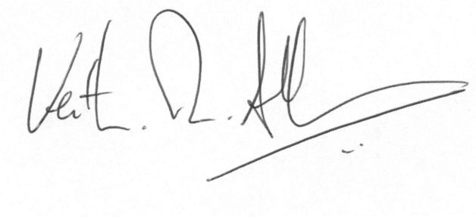
Rev. Dr. Keith R. Albans
(Superintendent Minister)

