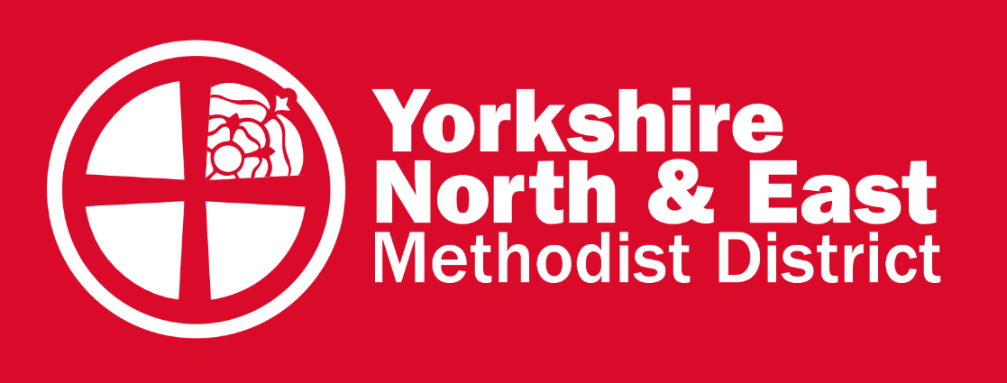

Yorkshire North and East Methodist District
Representative Synod 24th April 2021
Report from the District Safeguarding Officer, Katy Spencer-Madden

As in many cases, the work of safeguarding in the District has been impacted and affected over the past year due to the pandemic, however; adjustments have been made in relation to our ways working that has enabled important safeguarding work and ministry to continue.

There has been a decrease in issues reported over the past year, this is due to church closures, along with groups, activities and projects having limited meetings over the past year. Although specific details around safeguarding concerns remain confidential, this year I have dealt with and provided advice on some of the following:

- Concerns on welfare
- Safeguarding Contracts
- Allegations of abuse
- Cross denominational issues
- Exploration of allegations
- Prevention of access to children
- Church security and health and safety aspects of safeguarding
- Domestic abuse
- Online safeguarding
- Professional boundaries and conduct
- DBS checks and safer recruitment
- Policy and procedural matters

It is important that all safeguarding concerns and issues are reported to the District Safeguarding Officer within 24 hours.

Both delivery of the Foundation and Advanced Module has been delayed and hindered throughout the past year. The Foundation Module trainers in the District have taken part in Zoom sessions to explore how to deliver the new Foundation Module material (2020 Edition), although delivery of this in the Circuits still might not be possible face-to-face until later this year. The Foundation Module has been adapted recently to deliver online and some of the Circuits have delivered online Foundation Module sessions over the past few months. The Advanced Module is being adapted to deliver online and is expected to be ready this summer, with online delivery of the Module to begin in the autumn quarter.

It is important that DBS checks continue to remain up-to-date and the arrangement of doing document checks via Zoom or other online video communication platforms, will hopefully ensure that this can be done safely.

The District Safeguarding Group has continued to meet each quarter, having had many changes to membership recently. Special thanks to Rod Young and Michael Webster who served on the group for many years, both having stepped down last year. There are four new members of the group, expanding the range of safeguarding experience and expertise. We now have people from social work and police backgrounds, as well as church safeguarding, presbyters, digital communications, and Learning Network representatives. The District Safeguarding Group is currently preparing a Safeguarding Annual Return to gain a wider perspective of safeguarding within the local church context and how greater support, advice and guidance can be given to churches.

There is ongoing development of a Safeguarding Contract Oversight Group that will ensure the effective managing of all Safeguarding Contracts (a Safeguarding Contract is an agreement that helps manage the potential risk that an individual may pose to others) in the District. This group will report to the District Safeguarding Group. The group is still in the early stages of development, however; will hopefully ensure that Safeguarding Contracts can be managed with greater independency and support will be offered to all individuals involved in the Monitoring and Support Groups.

We are currently preparing for the first Virtual Safeguarding Conference. In previous years, the Safeguarding Conference has been a face-to-face event. This year the Conference will take place over the course of the week commencing 10th May 2021. There will be a variety of sessions throughout the week exploring how we use our gifts to serve God and others in ways that are safe. Places are still available to book on a session, please see flyer at the end of this report for further details. Follow link Meeting Registration - Zoom for booking.

The District Leadership Team adopted the District Safeguarding Policy last year, after recommendation from the District Safeguarding Group. It was acknowledged, due to the pandemic, there may be certain areas of the policy that are challenging to fulfil. As a District, we are committed towards strengthening our safeguarding practice in all areas of the District Safeguarding Policy – action plans have been developed to help achieve this.

