Synod Speakers, April 2021

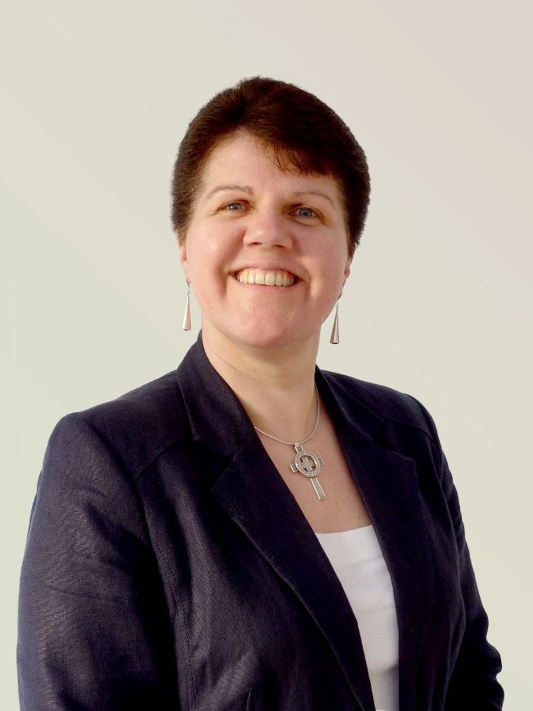
Deacon Eunice Attwood is the Methodist Church’s Church at the Margins Officer, a new position aimed at building on the biblical connection between evangelism and social justice and starting a movement of new Christian communities led by people who have been marginalised by society.
Eunice brings over twenty years’ experience of ordained diaconal ministry from a variety of contexts, including urban ministry amongst marginalised and vulnerable communities, where she helped start and grow many fresh expressions of church. Eunice also served as the Vice-President of the British Conference in 2010-2011. Eunice commented: “In the light of increasing economic poverty and the ever-widening gap between the rich and the poor, we need to embrace the commitment to be a Church at the Margins led by those at the margins, demonstrating God’s love revealed in Jesus Christ for all people.”

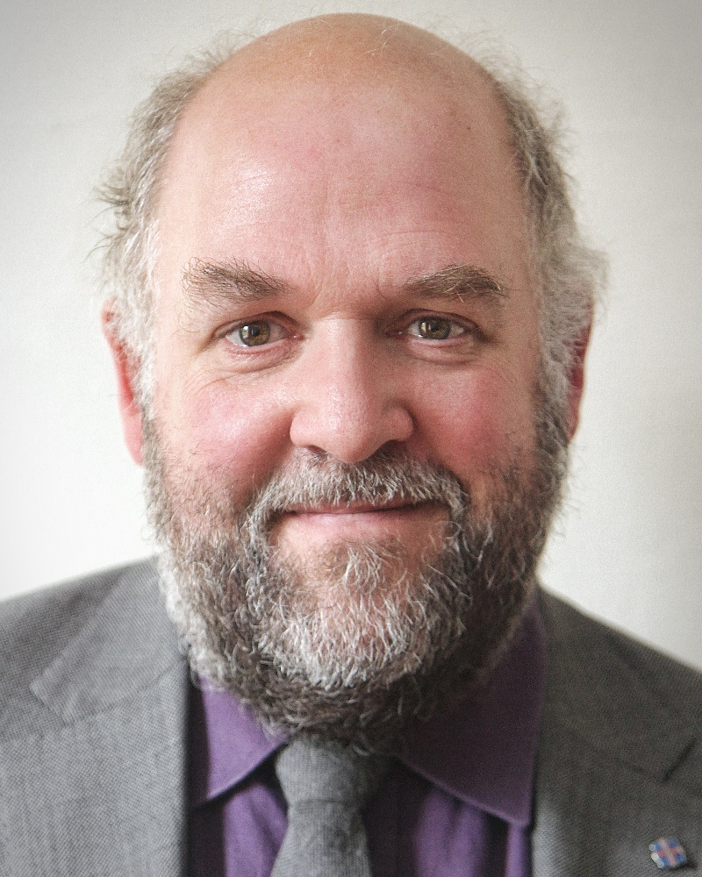
Revd Dr Pete Phillips is Director of the CODEC Research Centre at Durham University. With a PhD in John’s Gospel and many years’ experience of teaching /researching the New Testament, Pete now explores the interface between all things digital and theological! Pete has pioneered new ways of exploring Theology among the Digital Humanities and also developed the world's first MA in Digital Theology. Pete loves playing with tech, hacking new data, developing new opportunities for research.
With a background in New Testament teaching and research, I moved to St John's College, Durham in 2008 taking up the challenge to foster and develop, part -time, a cutting edge digital theology research programme at CODEC - exploring Biblical Literacy, Preaching, and Communication in a Digital Age. I also worked half-time for the Methodist Church as their Faith and Order Secretary.

