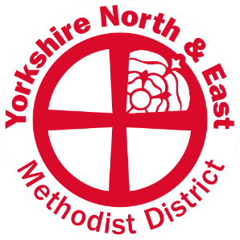

REASONED STATEMENT TO REPRESENTATIVE SYNOD SEPTEMBER 2020

Emma Crippen: Appointment of District Synod Secretary

Emma is a linguist and translator in the video game industry, with good administrative skills. She enjoys getting involved with her local church having recently moved into the District and enjoys engaging ecumenically and with those of other faiths. She has been involved in Methodism since University where she was Secretary of the Student Methodist Society.

Recommendation:

This recommendation is on behalf of the Yorkshire North & East District to ask Synod members to agree that Emma Crippen be affirmed as the new District Synod Secretary from 1 September 2020.

July 2020

