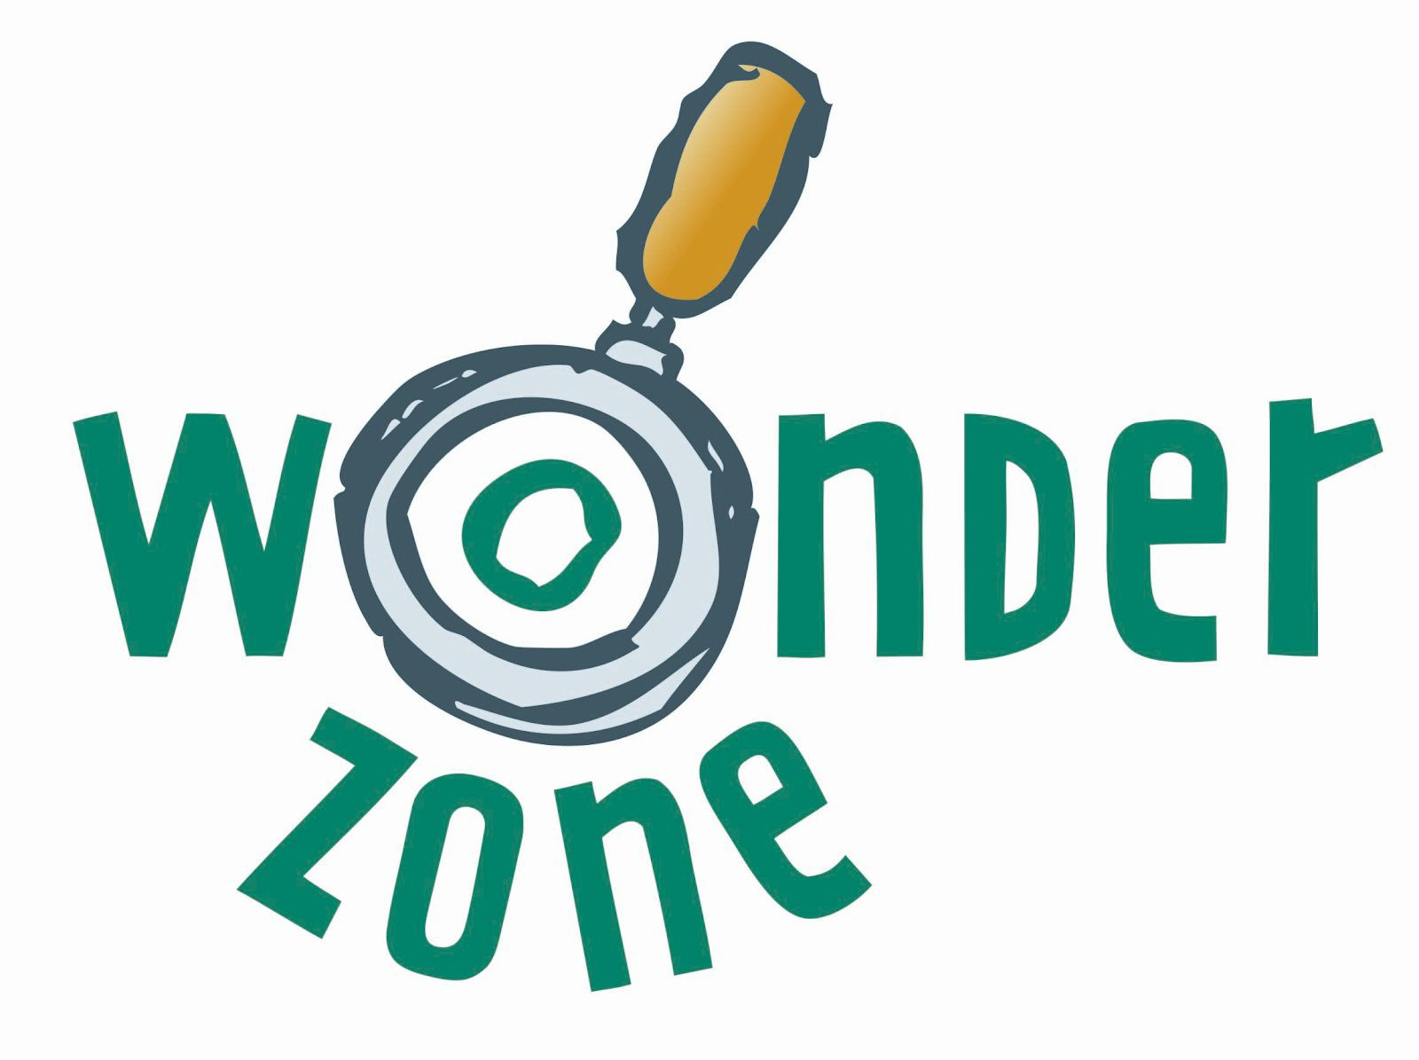

Session 1

Solomon asks for wisdom

Overview of the session

Bible Reading: 1 Kings 3:5-15 (NRSV)

At Gibeon the Lord appeared to Solomon in a dream by night; and God said, ‘Ask what I should give you.’ And Solomon said, ‘You have shown great and steadfast love to your servant my father David, because he walked before you in faithfulness, in righteousness, and in uprightness of heart towards you; and you have kept for him this great and steadfast love, and have given him a son to sit on his throne today. And now, O Lord my God, you have made your servant king in place of my father David, although I am only a little child; I do not know how to go out or come in. And your servant is in the midst of the people whom you have chosen, a great people, so numerous they cannot be numbered or counted. Give your servant therefore an understanding mind to govern your people, able to discern between good and evil; for who can govern this your great people

It pleased the Lord that Solomon had asked this. God said to him, ‘Because you have asked this, and have not asked for yourself long life or riches, or for the life of your enemies, but have asked for yourself understanding to discern what is right, I now do according to your word. Indeed I give you a wise and discerning mind; no one like you has been before you and no one like you shall arise after you. I give you also what you have not asked, both riches and honour all your life; no other king shall compare with you. If you will walk in my ways, keeping my statutes and my commandments, as your father David walked, then I will lengthen your life.’

Then Solomon awoke; it had been a dream. He came to Jerusalem, where he stood before the ark of the covenant of the Lord. He offered up burnt-offerings and offerings of well-being, and provided a feast for all his servants.

Link to storytelling video:

[https://www.youtube.com/watch?v=cfcMPFyNNro&list=PLvk5fboUt6LSZTn8JdVgvmofiNNeh](https://www.youtube.com/watch?v=cfcMPFyNNro&list=PLvk5fboUt6LSZTn8JdVgvmofiNNehrRHJ&index=2&t=1s) [rRHJ&index=2&t=1s](https://www.youtube.com/watch?v=cfcMPFyNNro&list=PLvk5fboUt6LSZTn8JdVgvmofiNNehrRHJ&index=2&t=1s)

Key Word:

➔ Discovery

Theme:

➔ Children may believe that they have to choose either science or faith – the session aims to set a positive and affirming tone for both and to encourage them on a journey of discovery about science and God.

➔ Faith and science are neither exclusive nor static

➔ Wisdom is being open to discoveries about the world God created and God’s relationship with the world and with us

Key points:

➔ Children may believe they have to choose either science or faith, but they can choose both

➔ This session aims to set a positive and affirming tone for both science and faith and to encourage them on a journey of discovery about science and God

Crafts

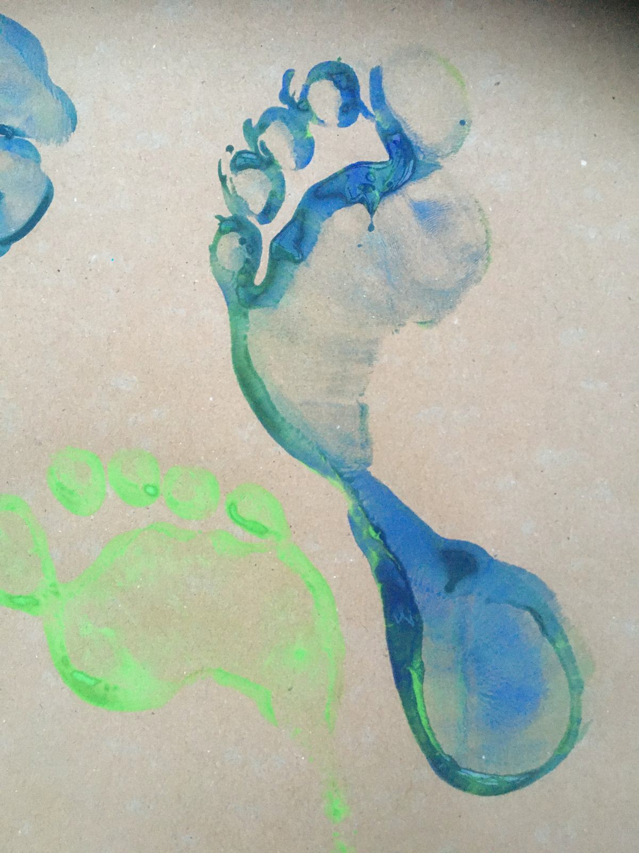

Resources needed:

➔

➔

Finger print/ footprints: Tray for paint, large piece of paper

Volcano: 200ml plastic bottle, small bowl, vinegar, bicarbonate of soda, washing up liquid, water and red food colouring

Splatter painting: toothbrushes Balloon splat: water balloons

String art universe: paper plate, string/ cord/ wool/ raffia, pom poms buttons

➔

➔

➔

Finger Print/ Foot print pictures

You will need:

Paper

Paint & tray to put it in

Soap and Water/ wipes/ kitchen roll

Blob some paint into the tray and stand in it or stick your fingers in it. Have fun making footprint and finger/handprint patterns and pictures

Junk Modelling challenge: Build an erupting volcano:

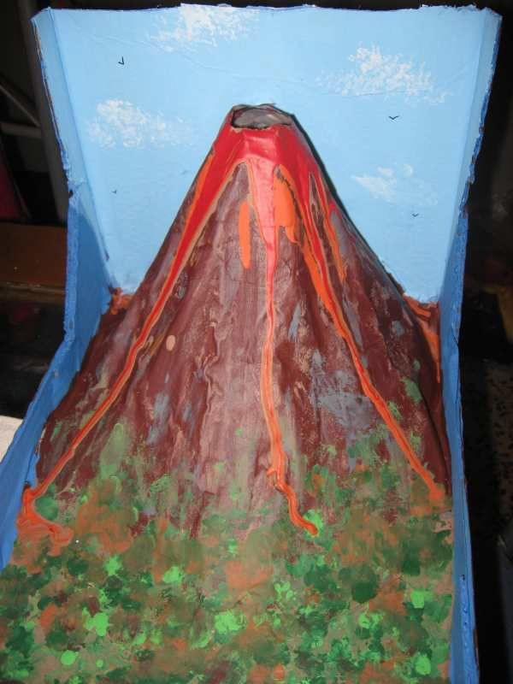

You will need:

200ml plastic bottle

Card or other materials to make the volcano shape Pencil

Scissors Tape

Paint and paint brushes

Things to cover up and clean up

For the eruption, you will need: Small bowl

1tbsp bicarbonate of soda (baking soda) 1tbsp washing up liquid

2 tbsp water

½ cup of vinegar

1 tbsp red food colouring

Full instructions can be found at <https://www.nhm.ac.uk/discover/how-to-make-a-volcano.html>

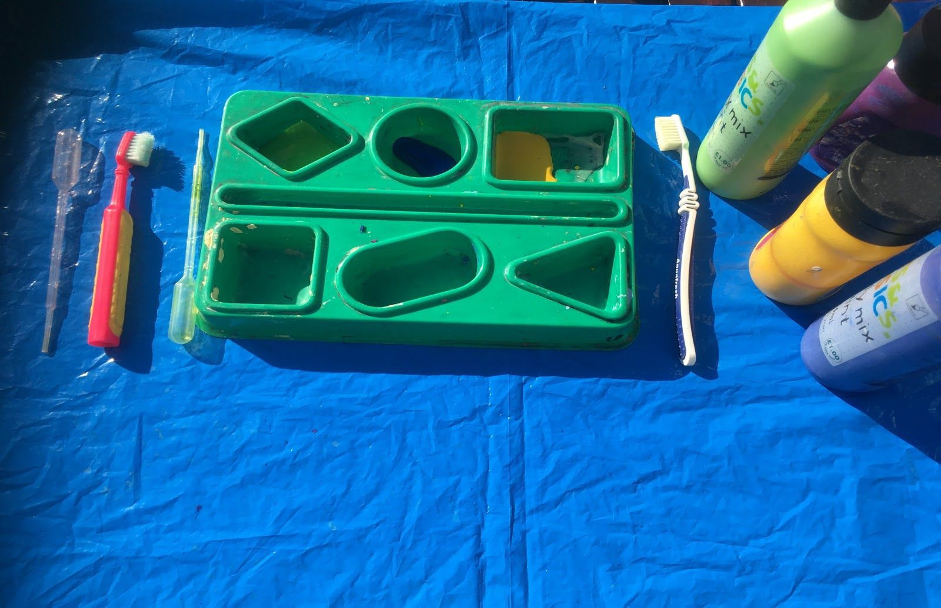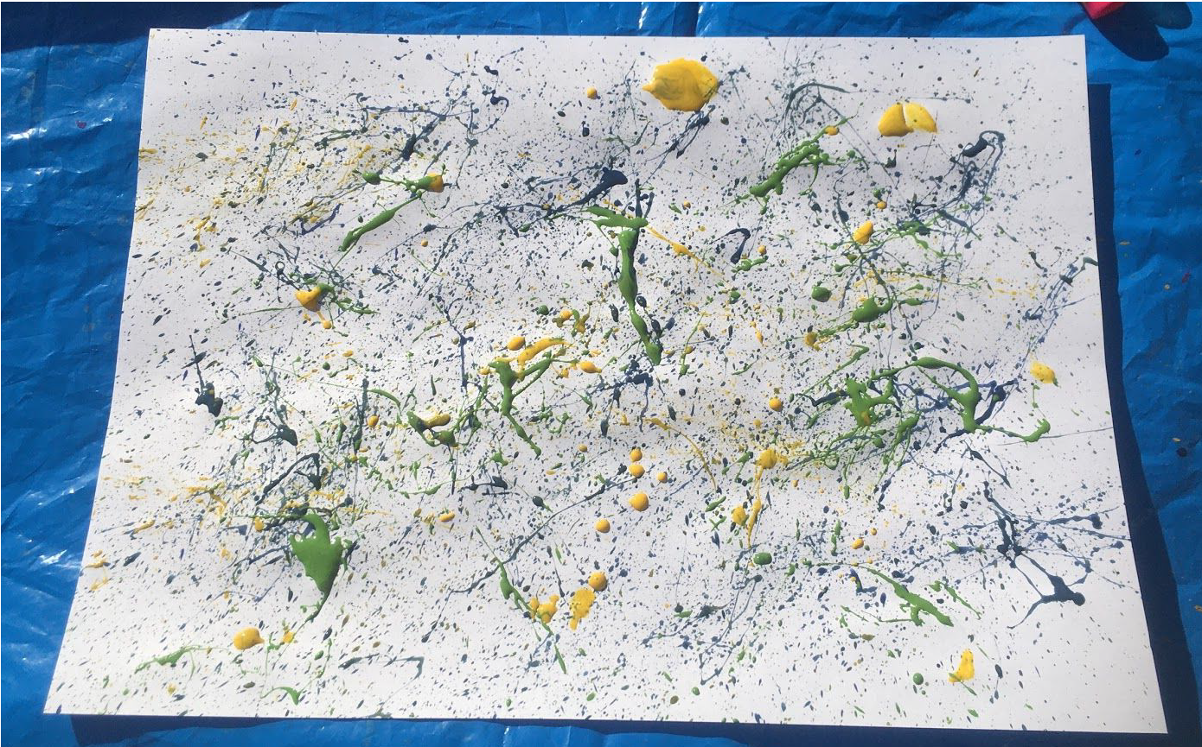

Splatter Painting

You will need:

Unused toothbrushes

Poster paint in different colours Large sheets of paper

Pipettes (optional)

Things to cover up and clean up

Dip the toothbrush in the paint and then hold it over the paper. Rub your finger along the bristles so that the paint sprays out onto the paper to make cool patterns like this….

See page 70 of the WonderZone resource book for more information

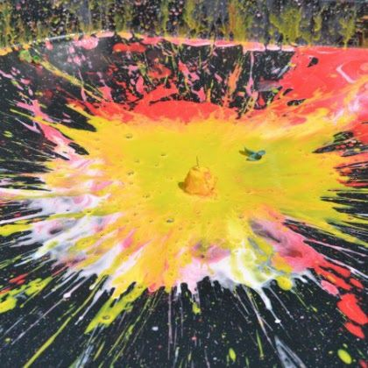

Balloon Splat

You will need:

Water balloons Paint

A large tray or hard surface

Clothes that you don’t mind getting paint on

For instructions & a description of doing this, visit <https://www.science-sparks.com/splatter-patterns/>

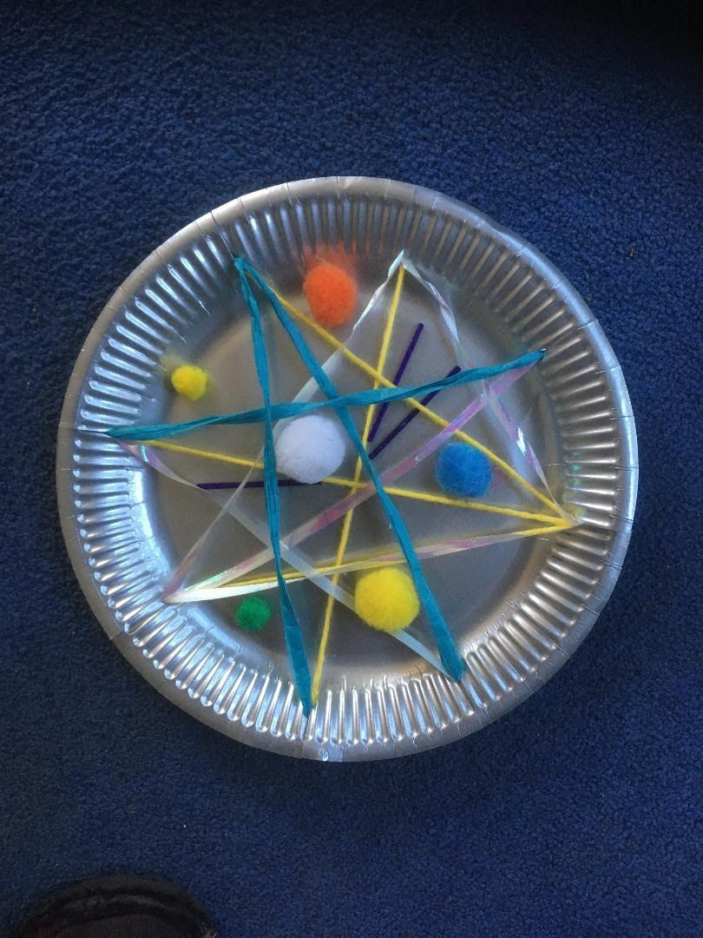

String Art universe

You will need:

Paper plate/round piece of card String/raffia/wool

Pompoms/ buttons/ star Glue

Instructions:

●

●

Cut 8 equally spaced slits in the outer edge of the plate.

Thread string through the slits and across the plate through another slit to make pointy patterns.

Stick on pom poms/ buttons/ stars

●

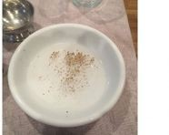

Science Experiments

Resources needed:

Shallow bowl or dish (pie dish works well if you have one) Water

Ground black pepper (other pepper works as well but is not as easy to see) Liquid soap; washing up liquid works best, but hand soap reinforces the need for handwashing more clearly

One half of a head of red cabbage (this needs some preparation - see below) Ice cube tray

Tall clear cups Vinegar Baking Soda

*Optional:* More acidic/basic household items such as lemon juice, washing soda, cream of tartar, or antacids

➔

➔

➔

➔

➔

➔

➔

➔

➔

➔

Pepper and water

Demonstrates why washing our hands with soap works, and teaches about the surface tension of water.

You will need:

A shallow bowl or dish Water

Ground black pepper Liquid soap

**Step 1**

Cover the bottom of your shallow dish with water.

**Step 2**

Sprinkle black pepper across the surface of the water. Note how the surface tension of the water causes the pepper flakes to float.

**Step 3**

Stick your finger in the center of the dish; did anything happen? Not much right? You probably just got some pepper flakes stuck to your finger. Now imagine that the pepper flakes are germs.

**Step 4**

Now dip the tip of your finger into the liquid soap—you don’t need much.

**Step 5**

Now stick that finger into the center of the dish. What happens? Your soapy finger chased those pepper flakes to the edges of the plate! Soap is formulated to break the surface tension of water, which is why it is so effective on dirty hands and greasy dishes. It wasn’t until you added soap to the bowl that those "germs" were chased away. This is the reason grown-ups are always nagging you to wash your hands with soap!

**Science bit**

The **pepper** is able to float on the **surface** because **water** molecules like to cling to one another. They arrange themselves in a way that creates **surface tension** on the top of the **water**. This **tension** keeps the **pepper** flakes floating on top instead of sinking to the bottom of the bowl.

**Water** molecules like to stick together. **Soap** is able to break down the surface

tension of **water**—that's part of what makes **soap** a good cleaner. As the **soap** moves into the **water**, and the surface tension changes, the **pepper** no longer floats on top.

For more information visit:

https://mommypoppins.com/boredom-busters/pepper-and-soap-easy-science-experiment-for

-kids-at-home

Cabbage water pH indicator

You Need:

One half of a head of red cabbage (pre-prepared as below) Ice cube tray

Tall clear cups Vinegar Baking Soda Water

*Optional:* More acidic/basic household items such as lemon juice, washing soda, cream of tartar, or antacids

**Directions:**

*To make the indicator solution:*

1. Chop up your red cabbage into small pieces. Place 2-3 cups in a saucepan and cover with water.

2.

Bring the solution to a boil and then turn off the heat. Let it sit for about 30 minutes to cool down.

Pour the cabbage water through a strainer into a jar or large measuring cup. The dark purple liquid in the jar is your indicator.

Pour your red cabbage indicator liquid into the compartments of an ice cube tray. Freeze for a couple of hours to make ice cubes.

3.

4.

*pH Experiment:*

1.

Fill one cup with water (this is neutral, or your control), one with vinegar (this is acidic), and one with a teaspoon of baking soda mixed with water (this is basic or alkaline).

Drop a couple of indicator ice cubes into each cup. Notice how the colors change in each one. Draw a picture of what you see.

Repeat with other acidic or alkaline/basic household items in other cups. Try to guess what colour the solution will be before dropping an ice cube in!

2.

3.

The colours change fast and should be delightfully brilliant and beautiful.

This is a fantastic way to introduce children to acid/base chemistry. And, who knows,

maybe they'll even get excited to eat some red cabbage, too!Science bit

Red **cabbage** contains a **water**-soluble pigment called anthocyanin that changes colour when it is mixed with an acid or an alkaline/base. The pigment turns red in acidic environments with a pH less than 7 and bluish-green in alkaline (basic) environments with a pH greater than 7.

[https://sites.google.com/site/sciencekiddoexperiments/make-your-own-ph-indicator-u](https://sites.google.com/site/sciencekiddoexperiments/make-your-own-ph-indicator-using-red-cabbageMaterials) [sing-red-cabbageMaterials](https://sites.google.com/site/sciencekiddoexperiments/make-your-own-ph-indicator-using-red-cabbageMaterials)

Link to videos of scientists talking about faith [https://www.youtube.com/watch?v=5NK170SV9B4&list=PLvk5fboUt6LSZTn8JdVgvmofiNNe](https://www.youtube.com/watch?v=5NK170SV9B4&list=PLvk5fboUt6LSZTn8JdVgvmofiNNehrRHJ&index=7&t=0s) [hrRHJ&index=7&t=0s](https://www.youtube.com/watch?v=5NK170SV9B4&list=PLvk5fboUt6LSZTn8JdVgvmofiNNehrRHJ&index=7&t=0s)

<https://www.youtube.com/watch?v=0d5mOA9Rtp0&t=4s>

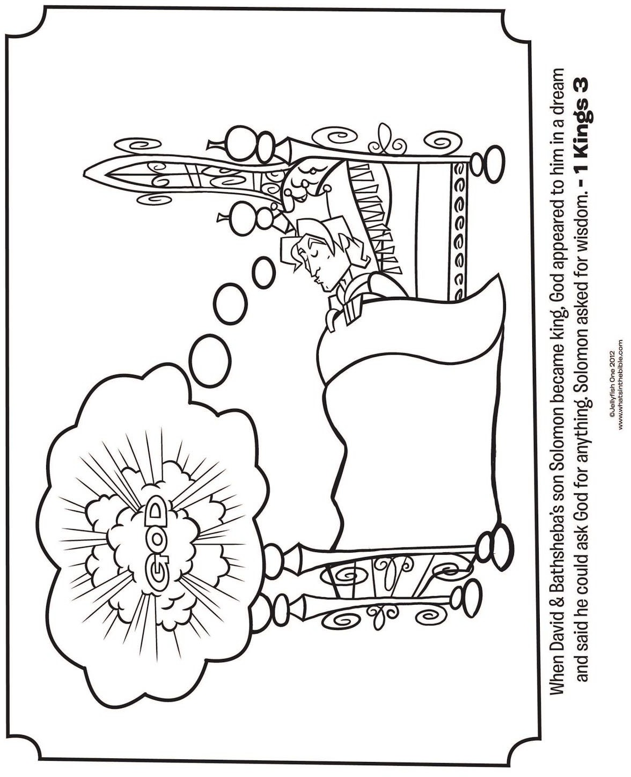

Colouring sheets and puzzles

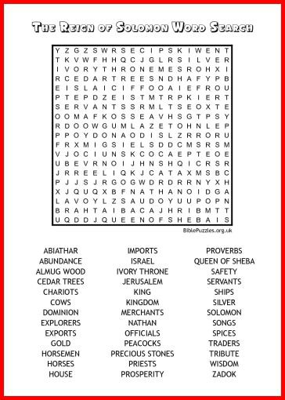

There are many colouring sheets and quizzes available on the internet. Try Googling ‘wisdom of Solomon printables’ and then clicking images for others.

Let’s Explore

Notes: If using Zoom you might want to use a whiteboard for writing or if parents are doing this at home you could suggest they use chalk to write on paving/driveways

The Fun of Discovery – 1 Kings 3: 5-15

Wisdom: Having experience and knowledge together with the power of applying them critically or practically. (Concise Oxford dictionary).

8-11 years

1. Write down any facts or fun facts that they know. Give help to anyone who hates writing. Share some of those facts.

2. Discuss what does the word wisdom mean? Read the story out loud or any good readers can volunteer. Encourage the children to look at their copy of the story underlining any bits they like and circling anything that surprises them. Share and discuss their answers.

3. Ask :What would they have asked for if they were King Solomon? If appropriate, ask the children why they would ask for that particular thing?

4. Ask what the children thought of King Solomon’s answer. Also discuss what is exciting about discovering new things.

5. Chat about what they might want to discover about God and science.

6. Draw out that faith and science look at the world in a different way. Science looks at how something works e.g. how a kettle works. Faith looks at why e.g. to boil water to make a hot chocolate.

5-8 years

1. Spot the difference sheet. How many differences can they find?

2. Explain what a fact is. Ask if they know any facts. Or give them some simple facts and ask them to guess is it true or not? (This might save a silence, caused by asking what facts do you know?)

3. Read from a suitable Bible (perhaps a children’s Bible?) 1 Kings 3:5-7 Can discuss questions like:

What type of things might you have asked God for?

Solomon said he was only a little child. How do you think he felt about being king?

4. Read the rest of the passage. Discuss what does being wise mean?

Encourage the children to produce their own poster with a drawing on what being wise means. Perhaps a picture of how they might be wise.

For both age groups allow time to share what they have discovered. Perhaps use sticky notes to write or draw something they have discovered.

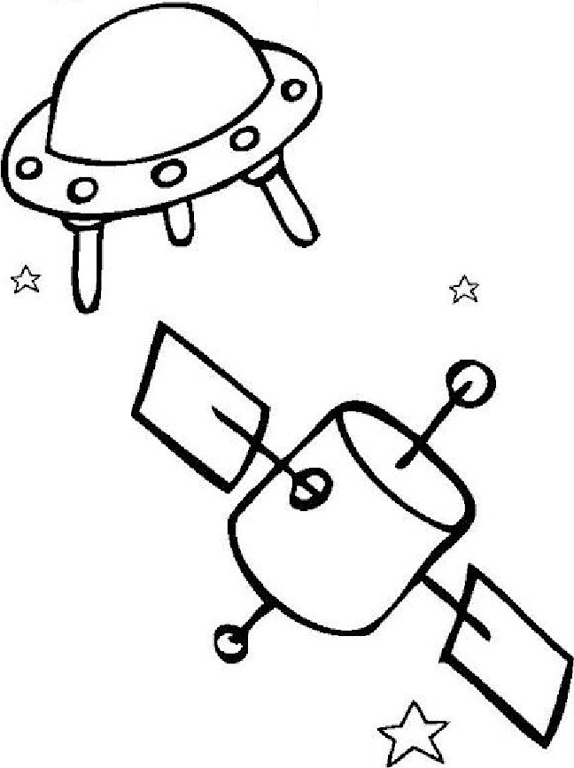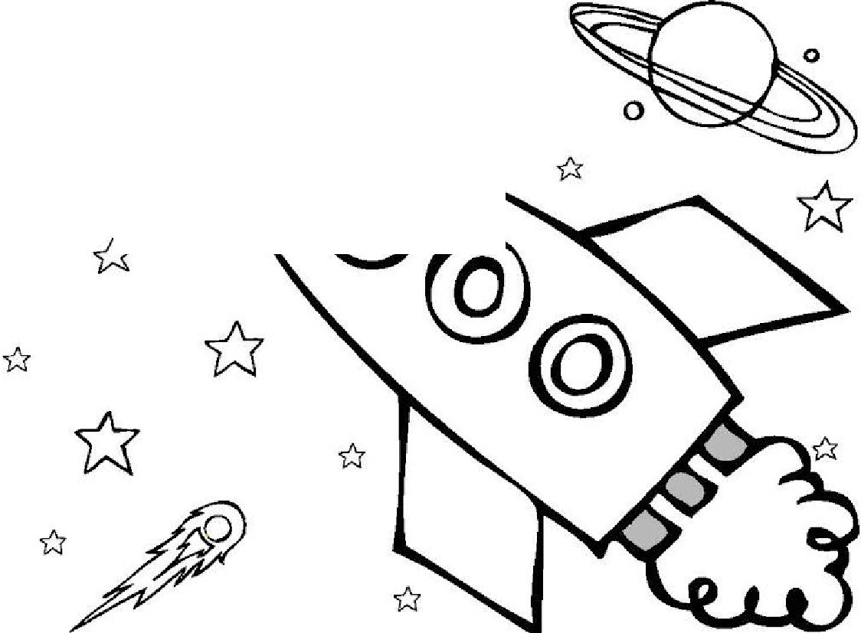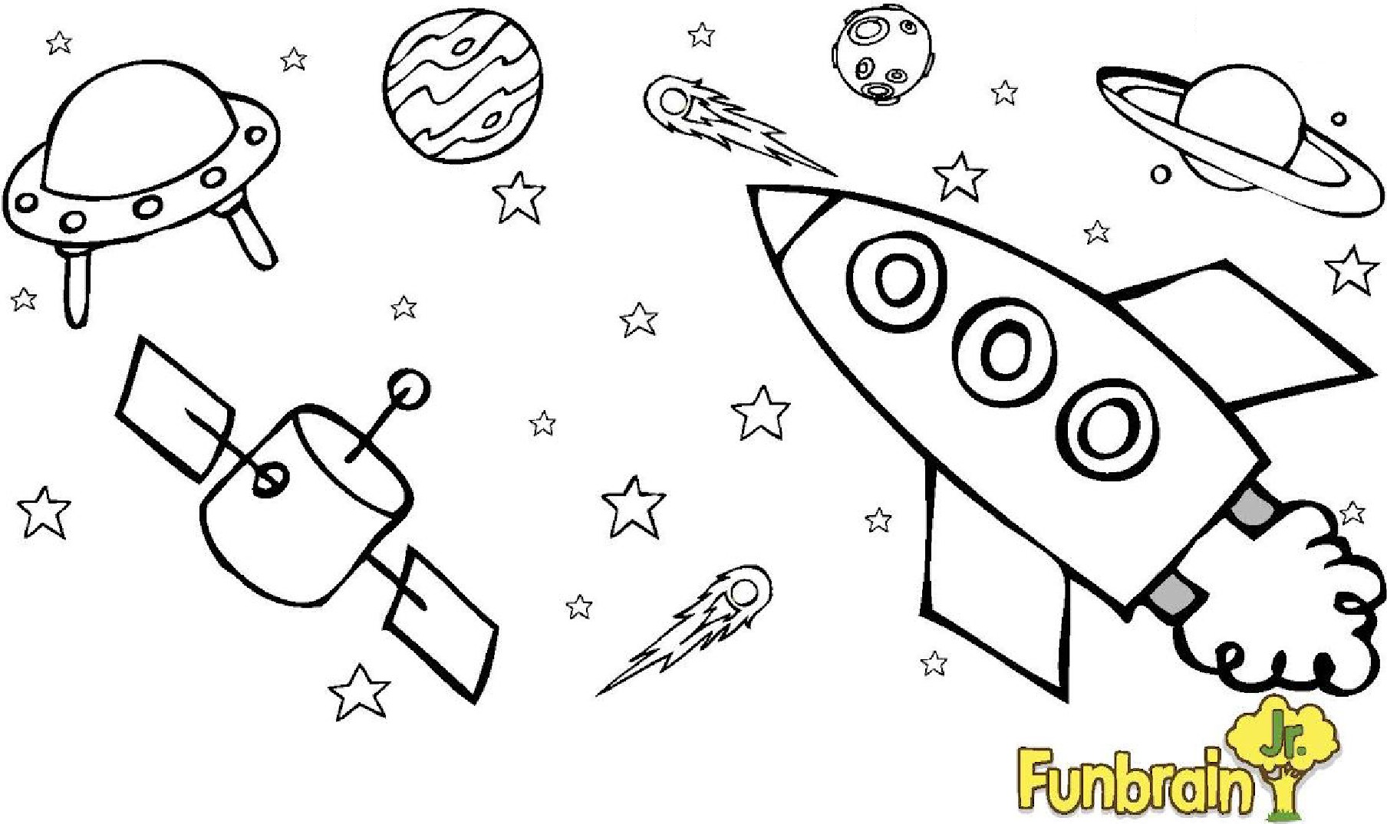

**Find the Difference**

Circle the

six differences you can find between these two pictures.

.o *

*

--------*

*0*

*

'

*

0 *

ww w.funbrainjr .com

© 20 13 Peorscn Edscatio'\ lnc. All ri9 t s reserved

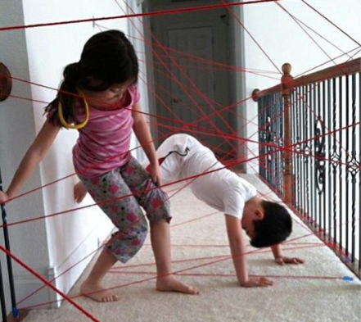

Prayer Space

Praying for Wisdom when overcoming hurdles

Set up an obstacle course before the session. It could be in the garden or in the house (safely!!)

As you go around the obstacle course, think about any ‘obstacles’ or ‘difficult things’ you come up against in your life. Or for difficulties other people may be facing right now.

Friends? Family? The people in charge of different things who have to make difficult decisions?

Ask God for wisdom for yourself and for others. Ask God to show you the way forward through these difficulties. God might show you that wisdom in many ways; maybe someone offers help at the right time or the right bit of information lands in just the right time. Maybe

an idea pops in your head. Maybe you need to be wise by being patient; God will answer you in God’s time….

Activities for older children/youth

Fruit salad

Wisdom can be a difficult concept to explain, making a fruit salad can help young people to grasp the difference between knowledge and wisdom. Some things are fruits e.g. tomatoes, but we wouldn’t add them to a fruit salad. Other things are vegetables e.g. rhubarb, but we wouldn't have them on the same plate as our Sunday roast and gravy. Ask the young people to do a little research and see who can find the most obscure vegetables and fruits.

With an older group you could discuss Frankenstein. Many people presume that Frankenstein is the name of the monster in the book of the same name, whereas in fact it is the name of the doctor who creates the monster. This is knowledge. But who is actually the monster? The creature Dr Frankenstein brings to life? Or the doctor for inflicting that fate on

the creature?

Lego activity

Solomon is credited with building the first temple. This became the permanent home for the Ark of the Covenant and according to the Bible took seven years to build. The story can be found in 1 Kings 6.1-8.66. What might this temple have looked like? You could ask the young people to do a bit of research about the temple, and perhaps to draw a plan or build it from lego or other building blocks. This could be used to start a discussion about what features from the temple still appear in churches today, why people build buildings for God, the nature of holy places and why people want churches to be reopened for prayer.

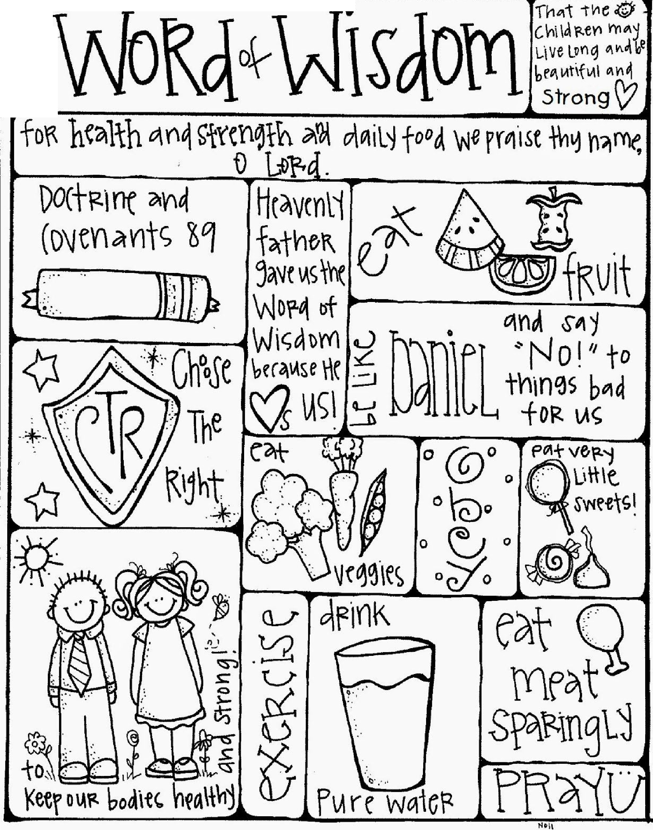

.

:

0..s:: ·

\-

•