Session 2
The Wondrous nature of creation

Overview of the session

Bible Reading: Psalm 8 (NRSV)
Divine Majesty and Human Dignity
To the leader: according to The Gittith. A Psalm of David.
O Lord, our Sovereign,
how majestic is your name in all the earth!

You have set your glory above the heavens.
Out of the mouths of babes and infants
you have founded a bulwark because of your foes,
to silence the enemy and the avenger.

When I look at your heavens, the work of your fingers,
the moon and the stars that you have established;
what are human beings that you are mindful of them,
mortals that you care for them?

Yet you have made them a little lower than God,
and crowned them with glory and honour.
You have given them dominion over the works of your hands;
you have put all things under their feet,
all sheep and oxen,
and also the beasts of the field,
the birds of the air, and the fish of the sea,
whatever passes along the paths of the seas.

O Lord, our Sovereign,
how majestic is your name in all the earth!

Link to Storytelling video
https://www.youtube.com/watch?v=BmPA9U_lnxc&list=PLvk5fboUt6LSZTn8JdVgvmofiNNehrRHJ&index=3&t=6s

Key Word:
- Creation

Theme:
- God’s creation is full of wonder
- The Big Bang Theory and Creation are not mutually exclusive

Key points:
- God is the creator of the universal and the personal
- The same God who created the universe created us and loves us

Crafts:
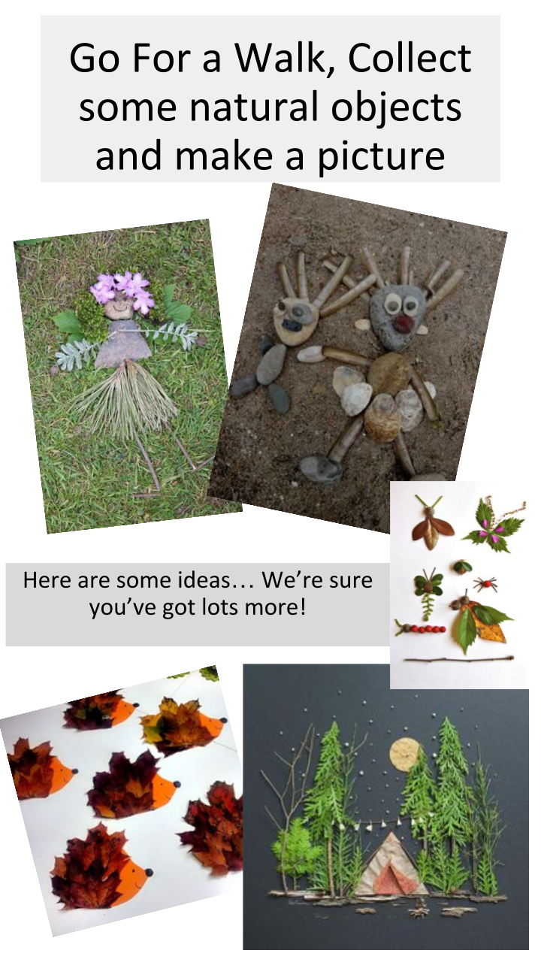
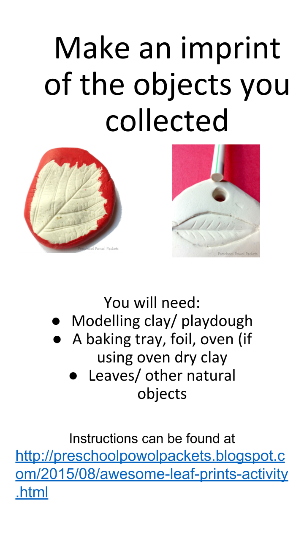
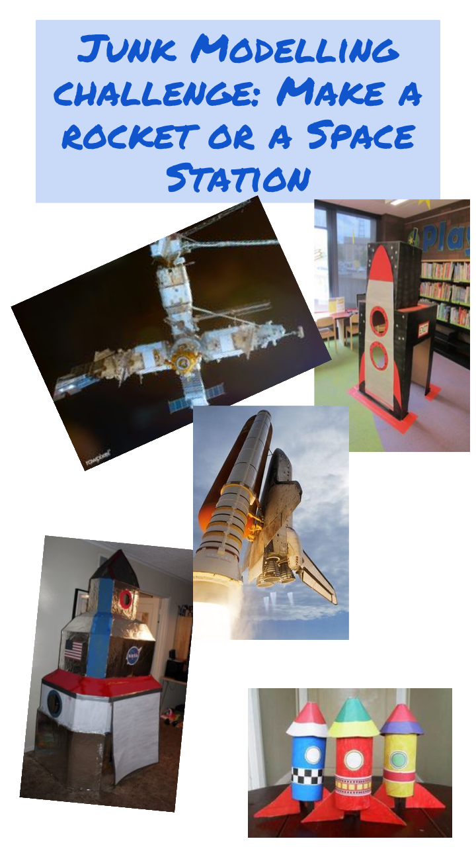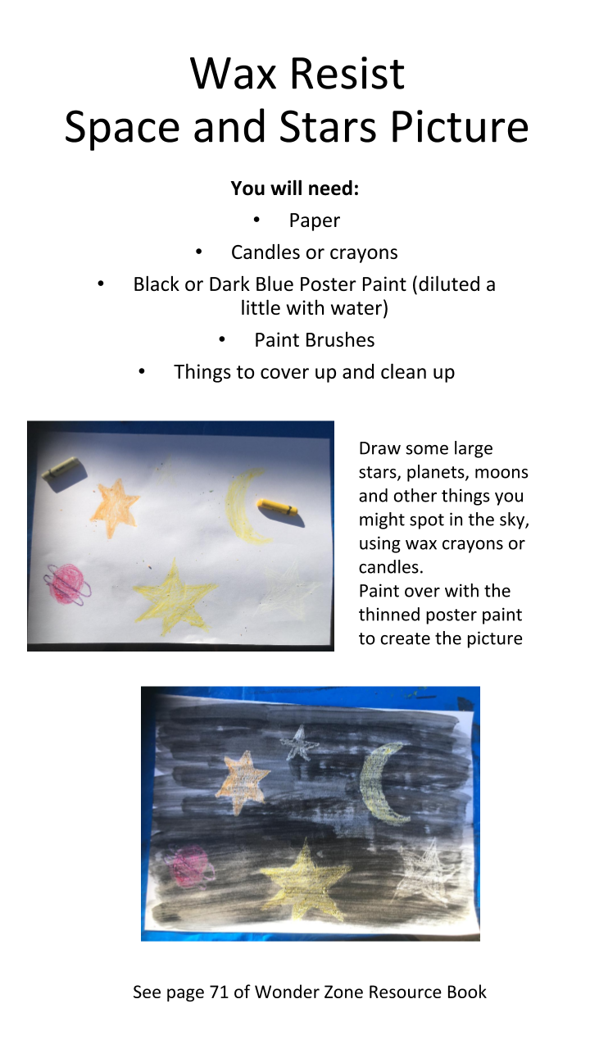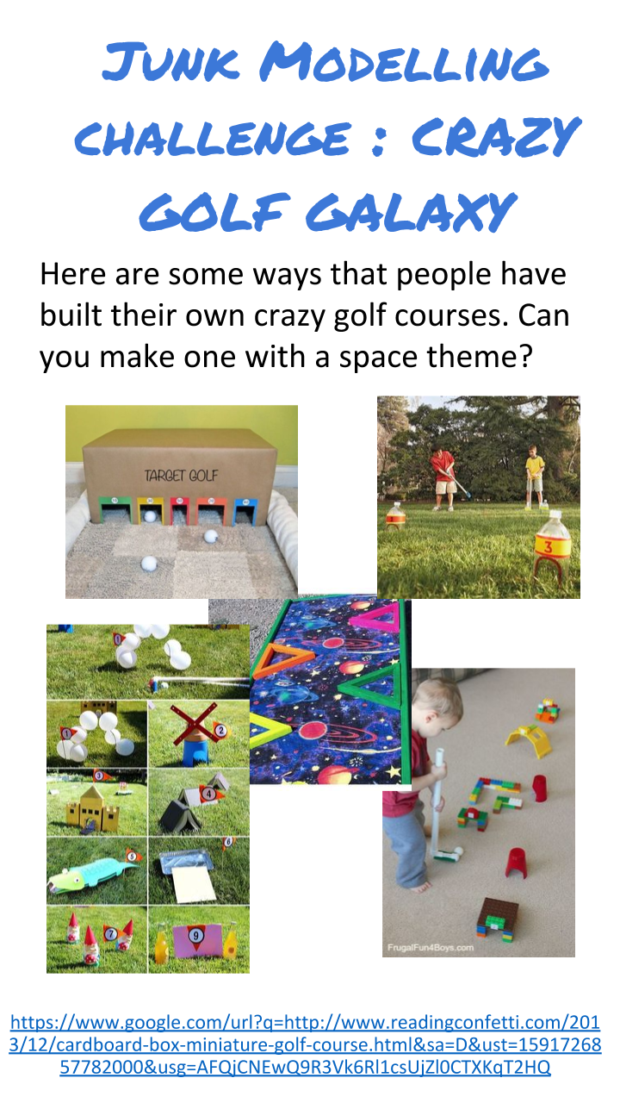Science Experiments

Resources needed:
- A wide bottle (or a fancy drinking glass or wide glass vase)
- Food colouring
- Vegetable oil
- Water
- Alka-seltzer tablet

Oil water lava lamp
Step 1: The Oil
Fill the container about 3/4 with vegetable oil. You can choose the size of the container based on how much vegetable oil you have to spare.
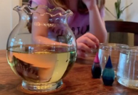

Step 2: The Water
Fill the rest of the container with water, leaving 2-3 inches at the top. Watch the water fall through the vegetable oil and settle at the bottom. Can you believe that water is more dense than oil? Water molecules are "polar" and oil molecules are "non-polar", so they are not attracted to each other in the least.
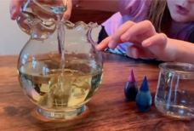

Step 3: The Colour
What colour would you like the "lava" in your lava lamp to be? After the water has settled for a minute or so, add your food colouring. About 10 drops should be enough, depending on how dense you want the colour to be. Watch as each drop falls through the oil and sits on top of the water layer. Wait until all of the water droplets break through the oil/water line and burst into the water.
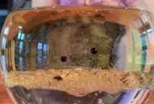

Step 4: The Bubbles
Drop your Alka-seltzer tablet in and let the games begin!
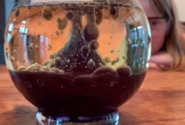

Science bit
The oil floats on top of the water because it is less dense or lighter than water. The food colouring has the same density as the water so it sinks through the oil and mixes with the water. When you add the tablet it sinks to the bottom then starts to dissolve. As it dissolves it makes gas, carbon dioxide, bubbles of which stick to the water droplets. The water/gas combination is less dense than the vegetable oil, so the bubbles rise to the top. The bubbles then break releasing the gas into the air and the water sinks back down to the bottom to start over again!

For more information visit:
https://mommypoppins.com/boredom-busters/science-experiement-make-a-lava-lamp-with-kids-at-home

Link to videos of scientists talking about faith
https://www.youtube.com/watch?v=IgePUOyA9mU&list=PLvk5fboUt6LSZTn8JdVgvmofiNNehrRHJ&index=8
https://www.youtube.com/watch?v=yUOTLVpajb8&list=PLvk5fboUt6LSZTn8JdVgvmofiNNehrRHJ&index=10&t=0s

Colouring Sheets and Puzzles
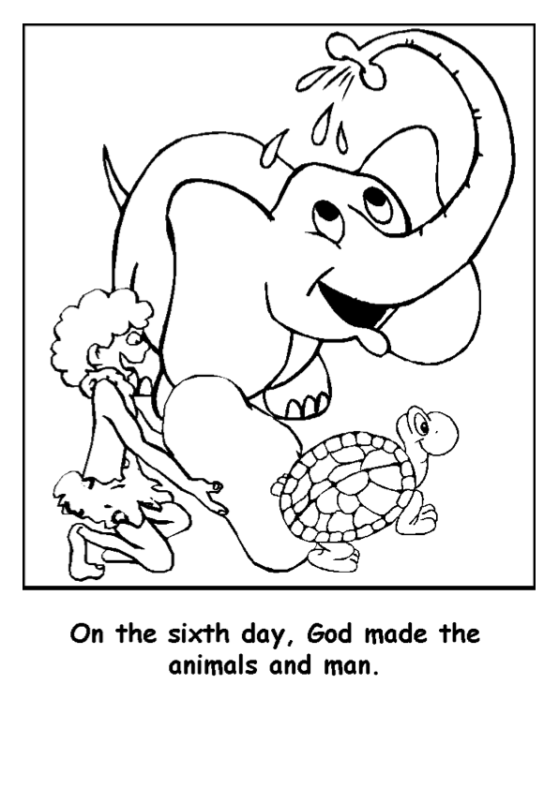
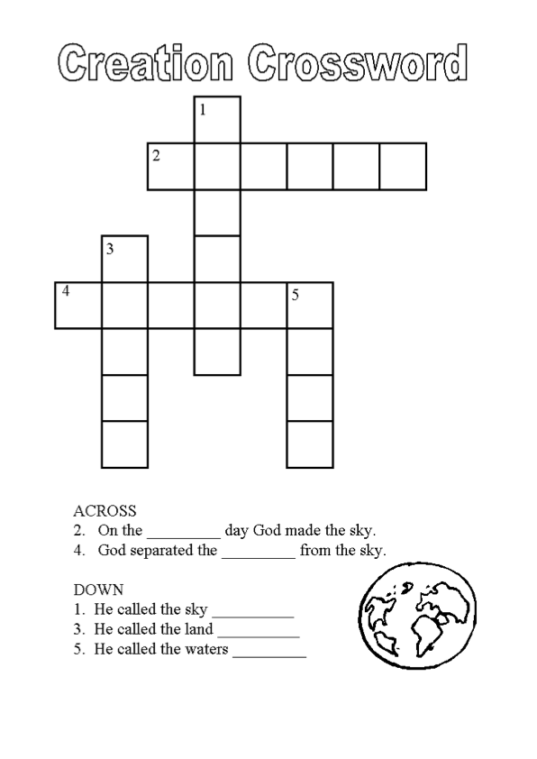
These are from http://www.dltk-bible.com visit their website for more free colouring and puzzle pages

Let’s explore

8-11 years
1. Have available any star maps, books on the Solar System, pictures or facts from the internet. Ask the children to come up with any space facts they know.

2.Discuss the thought that new discoveries are being made all the time about the Earth and space. Pluto was reclassified as a dwarf planet in 2006. They think there might be another planet beyond Neptune at the edge of the solar system, a rocky planet about 10 times the size of the Earth. (This is from looking at the strange behaviour of asteroids in the area.)

3. Read out Psalm 8. Give the children copies of the psalm with space so they can draw or doodle the sheet things inspired by the psalm.

4. Invite the children to share if they wish what they have drawn.

5. Share what verses 3 and 4 mean to you

6. Discuss what does the word, dominion means? What might it mean to us, thinking of looking after our world?

7. Ask if they are proud of things they have made. Do they think God is pleased with his creation? It is magnificent.

5-8 years
1. Do a matching activity using pictures of the planets as a remembrance game of finding pairs.

2. Chat about what the children have seen at night, when there’s no clouds. Show them pictures of the solar system.

3. Ask the children to lie down and close their eyes to imagine all the different things the writer talks about. Read the psalm, using basic language they can understand. Give them a copy of what was written. Encourage them to fill the spaces with pictures that illustrate the passage.

4. Chat about what part of the psalm the children like best? What does it tell them about God?

5. Ask them what they think is the most amazing thing about the world?

Prayer Space
Thank you for God’s Creation

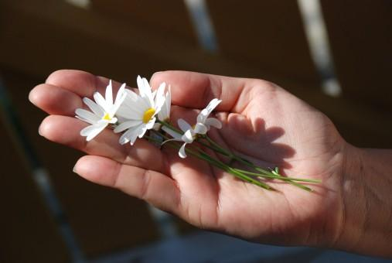
This can be done in a number of ways – choose the one which your family prefers. You can keep it simple and just use your hand, or you can draw around your hand and colour or paint your prayers. If you fancy an extra challenge, you can paint on your hands and do a hand print!! That would be a nice one to do outside for the mess!

As you think about each finger, think of some part of God’s creation you are thankful for. Maybe you have been thankful to be able to get out for a walk in the sunshine during this time. Maybe you have been thankful for your pets, or being able to grow sunflowers in the garden or for the food we eat.

If you are just using your hands, start off by holding one hand out. Use the pointy finger on the other hand and go to the bottom of your little finger or thumb. Take a deep breath in and ‘draw’ to the top of the finger or thumb. If you are in the garden, close your eyes and listen to the sounds of God’s creation. Breathe out as you ‘draw’ to the bottom of the finger or. Pray for the first thing or person you want to bring before God. Work your way around each finger in the same way, bring different things or people before God and saying thank you. Say it out loud if you wish or quietly in your head.

Activities for older children/youth

Creation vs the Big bang
Talk with the young people about what they understand about creation from Genesis and what they know about the big bang and evolution from school. Are the two reconcilable? Is it possible that God created the world using the big bang and evolution.
You could try comparing the two creation stories from Genesis 1 & 2.

Genesis 1 describes the seven days of creation:
- in the beginning - God started creation from nothing
- the first day - light was created
- the second day - the sky was created
- the third day - dry land, seas, plants and trees were created
- the fourth day - the Sun, Moon and stars were created
- the fifth day - creatures that live in the sea and creatures that fly were created
- the sixth day - animals that live on the land and finally humans, made in the image of God were created
- by day seven - God finished the work of creation and rested, making the seventh day a special holy day.

Some people think that Genesis 2 goes on to give more detail about the creation of humans, seen as two individuals, Adam and Eve.Adam was made from 'the dust of the ground' when God breathed life into him. Eve was created out of one of Adam's ribs to be a companion for Adam.

Main differences
There are some contradictions between the two accounts in Genesis 1 and 2, such as the order of when animals and humans were created:
- Genesis 1 - it states that animals, and finally humans, were created on day six
- Genesis 2 - it implies that humans were created before animals

What other differences do young people see in the accounts?

Science Biographies
Before meeting with the young people do a quick google search for some famous scientists, is it possible to be Christian and a scientist? Here are a few to get you started.
- Francis Bacon; credited with establishing the inductive method of experimental science via what is called the scientific method today.
- Robert Boyle; Prominent scientist and theologian who argued that the study of science could improve glorification of God. He is considered one of the most important figures in the history of Chemistry.
- Isaac Newton; Prominent scientist during the Scientific Revolution. Physicist, discoverer of gravity
- Louis Pasteur; French biologist, microbiologist and chemist renowned for his discoveries of the principles of vaccination, microbial fermentation and pasteurization

Alternatively watch some of the scientists on the Wonderzone videos talking about their faith. The links can be found here https://www.youtube.com/playlist?list=PLvk5fboUt6LSZTn8JdVgvmofiNNehrRHJ

