Contactless Giving

Card payments in church for regular giving (collection), one-off donations, sales of goods or services (Fair Trade items, funeral fees…)
There are two kinds of units:
- Attended – these are small, cheap, rechargeable, hand held devices that rely on a person with the associated app on their smartphone (Android or Apple) inputting the details of the transaction
- Self-sufficient – these have their own network capability so don’t rely on a controller inputting information. They are small, hand-held devices which can be passed around or mounted in fixed unit.
Costs
- Initial unit fee, around £25 for attended devices, £100 for self-sufficient devices (possibly plus chargers, mountings) – phones or tablets needed for attended devices
- A transaction fee of around 1.75%
Operating process
- Both
- Needs an account to be set up in one person’s name
- Other operators can be added by account holder

- Attended units
- Works with an app on a phone
- Needs several people to commit to being operators (merchants), downloading the app on their phone, if used at services (unless church buys a phone and contract for this purpose)
- Merchant inputs amount (up to £30) on phone app and passes unit to card holder
- Speed and confidentiality can be improved by having pre-set ‘products’, in this case pre-determined donation amounts, which appear as icons on the phone screen

- Self-sufficient units
- Does not need a transaction manager, givers input their own amount
- Most have card slots for chip and pin payments
- Can be hand-held or mounted
- Could be used alongside the collection plate
- Needs good phone signal (don’t know which network they use)
Pros and Cons
- Attended units
- Pros – cheap, churches could have several, easy for a minister or administrator to use to accept payments, reduces security and fraud issues of cash handling
- Cons – need several committed individuals if used for giving, lack of confidentiality, relies on church wifi system, too cumbersome a process to use in a traditional ‘passing the plate’ way, only works for amounts up to £30 as relies on contactless system

- Self-sufficient units
- Pros – does not require a wide support system, improved confidentiality, uses built in 3G signal (could be a ‘con’ in some areas), can be fixed or mobile, no transaction size limit, reduces security and fraud issues of cash handling
- Cons – cost
Reporting and accounting
- Only when products are pre-set will they appear as identified items in the app’s reporting. That might not be an issue for giving as cash amounts are not currently identifiable.
- Gift aid would still need to be claimed manually with an additional note to identify card payments
- Without linking to a printer, there are no receipts. Units that allow for phone numbers/email addresses to be input will send electronic receipts. Again, does not happen now for cash transactions so probably not an issue
Providers
- SumUp
- iZettle
- VivoPay
Additional information
- Some systems can be used to take payments over the phone by emailing a link to an online payment portal
Feedback
- Churches using any of the systems have seen an increase in giving
- Collection plate takings generally remain the same, card payments are extras
- One American church gave up the plate-passing altogether and asked people to make their donations via fixed units in church

Images
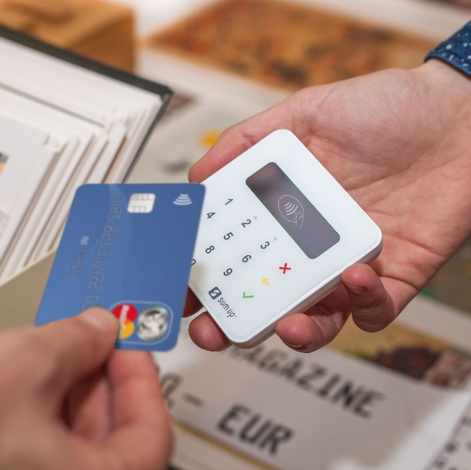
Attended unit, contactless only (this image is somewhat deceptive as it does not show the mobile phone that is necessary for this transaction)

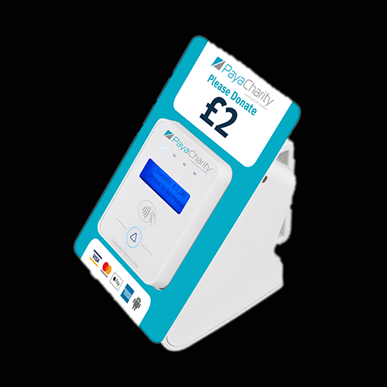
Self-service, table-top, contactless only unit set to a fixed donation of £2

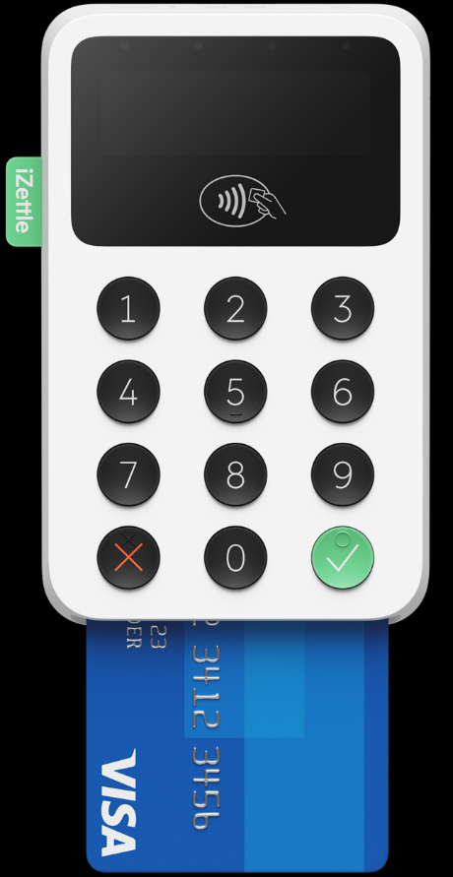
Self-sufficient unit with chip and pin capability →

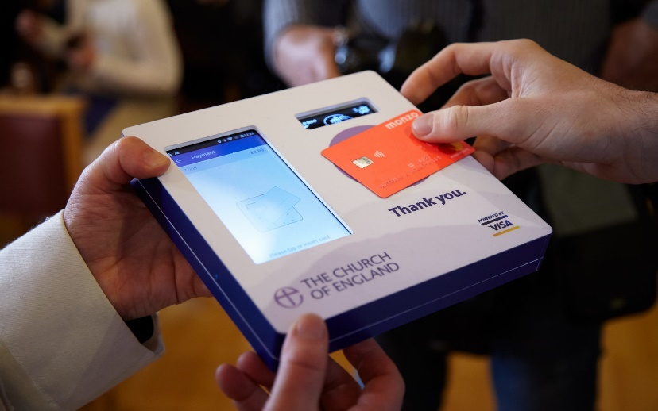

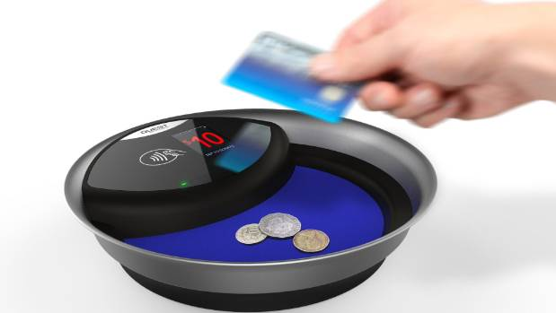

Bespoke, contactless only units designed to replace or supplement regular collection plates.

Videos showing use of attended contactless units in the Church of England https://vimeo.com/album/5118798

Conclusion
- Contactless has the benefit of speed and simplicity and is fine for regular giving where amounts are likely to be under £30, but the involvement of a third party with a mobile phone is cumbersome and off-putting
- Taking contactless payments by passing round a hand-held, self-sufficient unit alongside the traditional collection plate could be tried, but it would need to take place throughout a longer section of the service as it would take time. That could be distracting for the giver and others.
- The combined cash and card plate in the image above has the card donation set to one amount only which would speed up the process – just tap and pass on. (This one was made specifically for an Australian cathedral and is not commercially available)
- A self-sufficient, fixed terminal in church with an encouragement to people to use it to replace their ‘plate giving’ if they wish to, and which could also be used for specific fund raising, might be useful.
- Removing the passing of the plate entirely is an option, with a plate for cash payments and an electronic terminal located elsewhere in the church – would remove the ‘pressure to pay’ factor, which could be seen as a pro or a con.
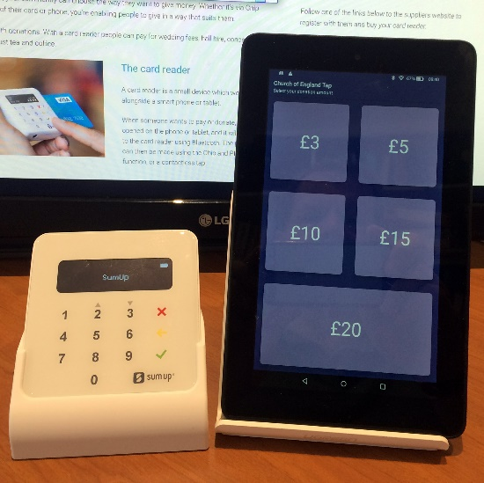
- A major benefit of app-based units is the pre-set donation amount icons which remove the time and hassle of setting up your own transaction. This image seems to suggest that you could take the attender out of the attended unit situation by linking it to a fixed tablet. It looks attractive and easy to operate – touch the icon, tap your card – and would cost £25 for the card reader plus a cheap tablet connected to church wifi. It would need people to take responsibility for setting up and taking down at services and events but would not require several individuals to use their own phones.

