FAIR TRADE

‘Fair Trade and care for the planet is a theological issue. The more dominant we become, the less caring?’

‘To what extent do we feel the Methodist Church has a part to play in modelling support for sustainable initiatives such as fair trade, living wage, installing sustainable energy sources and food share schemes?’

As part of the District’s commitment to Fair Trade we attempted to get District Fair Trade status in the noughties. Diane Robinson, our Fair Trade representative at the time, put a huge amount of effort into this. To attain District status we had to have a percentage of circuits signed up to be Fair Trade circuits which in turn depended on their encouraging the churches within the circuit to obtain Fair Trade status. Whilst many were keen to do so, others were more reluctant claiming that tea and coffee displaying the Fair Trade logo was ‘awful’ and their congregations would not drink it. After an exhausting time of trying to encourage and cajole people into signing up for a Fair Trade certificate it became clear that we would not be able to attain District Fair Trade status. Now that we are a new District we would have to start all over again if we still wished to acquire Fair Trade status. Based on previous experience this would not seem to be a sensible course of action.

As time and circumstances have moved on, and in general people are more aware of the need to consume and use goods that have been fairly sourced it is worth another look at how, as churches, we respond to Fair Trade issues. Other labels such as ‘obtained from sustainable forests’ have appeared and it seems that now is an appropriate time to re-examine our commitment to being a District which encourages churches to be Fair Trade churches, and to ask them to consider the effectiveness of their commitment to the principle if they have already got that status. Unlike many other organisations the status of being a Fair Trade Church does not require renewal for which we are very grateful. It does, however, place the onus on us to police our own commitment to maintain the standards required. This leads us to ask several questions.

- How many of our churches in the District are Fair Trade churches?
- Do those that have committed themselves to being Fair Trade churches have a certificate on display?
- How well are those that have declared themselves to be Fair Trade churches auditing the purchases of tea and coffee by a) Church organisations and b) Groups using their premises to ensure that the products they use have the Fair Trade logo?
- As DPC do we want to encourage churches to seek to be Fair Trade churches if they do not already have that status.
- Is it worth reminding those that are Fair Trade churches of their responsibility to maintain that commitment and encourage other church users in the use of FT products?

Depending on some of the answers to the above questions what are the options for the District?

- Do nothing and leave things with individual circuits and churches
- Encourage all circuits and churches to consider their position with regard to Fair Trade products and to act accordingly
- Encourage churches who are happy to accept Fair Trade status to ensure that they have a certificate on the wall and are committed to maintaining the status.
- Actively challenge churches we visit when served with tea or coffee that does not have a FT logo or anything else which is deemed to be acceptable as a mark of fair trading.
- Suggest they go one step further and encourage churches to offer all lettings free Fair Trade tea and coffee for a month to persuade them it can be FT and taste good.

Some points to consider

Fair Trade and examples of other Coffee and Tea Certification Schemes

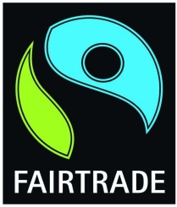 | Fair Trade stepped into the void left by the collapse of the International Coffee Agreement in 1989 which resulted in a horrendous drop in world coffee prices and threw many coffee farmers into desperate poverty. It is primarily concerned with alleviating poverty through greater equity in international trade. Many products beside tea and coffee can be certified as ‘fair trade’. Certification is only available to democratically organised
cooperatives or associations of small producers, not individually owned farms or estates, or those that rely heavily on hired labour.

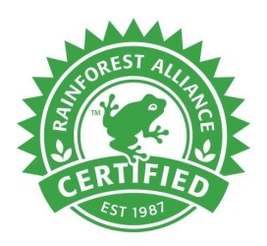 | Rainforest Alliance is an NGO with programs in several areas that promote standards for sustainability. Not exclusively an environmental certification it also covers a number of ecological issues as well as community relations and fair treatment of workers. Certification is based on a score for meeting a minimum number of criteria. There is no way to distinguish which or how many of the criteria have been met. There is no
minimum price set but producers can use the certification to negotiate a better price for their coffee. Buyers need to examine the seal on the coffee as the Rainforest Alliance allows the use of its certification on coffee that contains only 30% certified beans. An indication of the proportion is indicated on the seal.

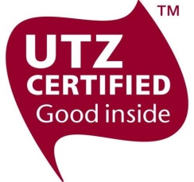 | UTZ Certified Their emphasis is on transparency and traceability in the supply chain and efficient farm management. The latter includes good agricultural practices such as prevention of soil erosion, minimising water use and pollution, responsible use of chemicals and habitat protection. Certification requires compliance with mandatory control points. It is given to farms working towards the criteria and there is no way to distinguish how many of the criteria have been met. No minimum price set.

NOTE The Rainforest Alliance and UTZ plan to merge by the end of 2019 and keep the Rainforest Alliance name.

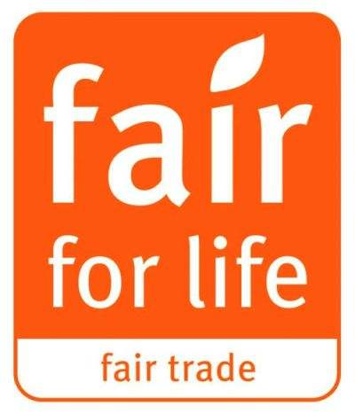 | Fair for Life Probably the best certificated scheme. Originated in Switzerland in 2006. It has received much praise for its social and enviromenmental requirements which are more comprehensive that other schemes. It certifies the whole company group and also the producers and manufacturers in developed countries which Fairtrade does not. It is very transparent and all data is published on its website. It doesn’t have a fixed
price but does have a premium and minimum price negotiated between buyer and seller. The premium is typically 10% on top of the market price.

There are also several other forms of certification including Soil Association Organic standard certification schemes, ethical tea partnerships. bird friendly habitat certifications etc.

The Sainsbury’s Foundation and Fair Trade

There is currently a disagreement between Sainsbury’s and the Fairtrade Foundation over the introduction of a pilot certification by Sainsbury’s entitled ‘Fairly Traded’. They have invited the Fairtrade Foundation to be part of the pilot project but the Foundation have declined having consulted their producers. Sainsbury’s is the biggest retailer of Fair Trade goods so it is an important disagreement. Sainsbury’s have declared their own brand Extra Strong, Green Tea, Red Label and Gold Label ranges will no longer be Fairtrade certified and will instead become part of their own Fairly Traded range. The Fairly Traded range will be certified as such by Sainsbury’s themselves under a self auditing process. In addition to this the premium paid to the producers will only be available to them on application to a London based board. This adds a further level of bureaucracy to the process and the farming groups in Africa have indicated they do not want their money to be controlled by a group removed from the day to day life in Africa and elsewhere. We wait to see the outcome of this dispute and the success of the pilot scheme.

Heather Shipman
January 2019

