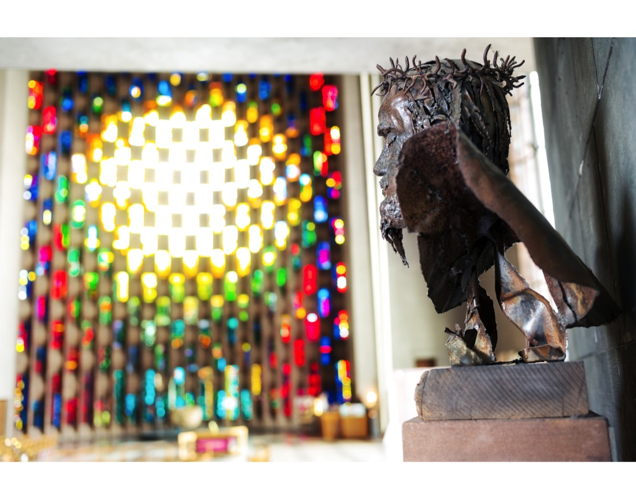

**HULL (CENTRE AND WEST) STRATEGIC REVIEW 2013-14**

Circuit Leadership Team report to the Circuit Meeting

**Mark 8:34**

If any want to become my followers, let them deny themselves and take up their cross and follow me



## Proverbs 29:18 (AV)

Where there is no vision, the people perish

*CROSSINGS OUT*

**HULL (CENTRE AND WEST) CIRCUIT MISSION POLICY**

POLICY CONTEXT

The Hull West Circuit celebrates and cherishes the day to day life of our churches and the many ways in which they live out the gospel together and seek to be an effective Christian presence within their communities. Such loyal and loving service is the bedrock upon which this mission policy is built. Traditional Churchgoing to Christian denominations has long since ceased to be a common activity for the younger generations in society, and faith itself is seen to be increasingly at variance with the secular world view which predominates today. This mission policy provides a robust response to these trends and paves the way for building a bright and sustainable future in our Hull West Circuit and beyond.

POLICY

1. We believe that we are called together by God to be Spirit-led, with a heart for Jesus and a

passion for mission. This belief shapes our decision making, our vision and the allocation of

our God-given resources and leads us to identify our key priorities for mission. As a Circuit we

will seek to support and resource work which meets one or more of the following objectives,

and which can be either church or Circuit led:

a. Making new disciples and growing in discipleship

b. Establishing fresh expressions of church and church planting

c. Initiatives in mission-shaped ministry

d. Community focused social action

e. Work with families, young people and children, and older people

f. Reaching the missing generations

g. Building community cohesion

2. We will consider seeking both funding and partnership with other organisations that offer us the

freedom to fulfil our gospel imperative, in order to maximise our impact and effectiveness.

3. We will encourage each of our churches to shape its life and witness around these priorities

and to be active ‘centres of mission’ with the full support of the Circuit.

Notes to the Policy

i. Only by honouring what we already have, can we do justice to the faithfulness of the Methodist people who worked so hard to establish and maintain our witness in this area. Our predecessors pass on to us their precious missional inheritance and give us the responsibility of deploying these resources in order to do God’s work today.

ii. We recognise that major cultural shifts since the second world war have had a deep and abiding impact upon the context of our life and witness as Christians.

iii. We are all well aware that we face a tough missional challenge if we are to survive, let alone prosper.

iv. As a grassroots discipleship movement shaped for mission, Methodists have always been Spirit-led.

v. Because our resources of staff and money are finite they must be deployed with great care. It follows that the Circuit will want to use its resources in pursuit of these priorities, as these are the ones which it has identified as being critical to us being an effective Christian presence in the area we are called to serve.

vi. We recognise that some churches may prefer to identify themselves primarily as centres of fellowship rather than centres of mission and we value the support with which, by their prayer and worship, they nourish and enhance the life of the circuit. The designation, centre of fellowship, does not mean they will receive reduced pastoral care but it simply recognises what is true on the ground when it comes to mission. In such communities the Circuit would expect to take forward fresh initiatives in mission if it was deemed important to do so.

**CONTENTS**

Circuit Mission Policy

Introduction

Process

Theological rationale

The Grace of Giving

Questions used

Summary Data Table for the churches

Analysis and Interpretation

Application from Church Council for designation as a Centre of Mission

Review of centres of mission

**INTRODUCTION**

Our Circuit is currently in a position of relative financial strength. We have excellent and committed staff (ordained and lay) and, with over 1000 members, we are numerically bigger than New Life, Jubilee or the Community Church. Because we worship in 21 different places we can lose sight of this important and encouraging fact. In 2012 we adopted a new Mission Policy and set about creating a brand new Circuit, which happily came into being in September 2013. As the new Circuit was being formed we also set ourselves the crucial task of addressing the Circuit’s finances, with a view to eliminating the growing deficit and deploying our resources wisely and well in accordance with our missional purpose.

The Circuit currently has strong reserves but is making a deficit on its General Account each year, which is gradually eroding our reserves. This deficit is projected to increase quite sharply over coming years hence action needs to be taken now to either increase our income (Circuit Assessment), reduce our expenditure or achieve a combination of the two. We have already decided to reduce our Ministerial staff by one at the end of 2013/14 and may have to reduce by another Minister at some stage in the future. Equally we will need to assess whether we can afford to retain all of our existing lay staff positions.

Our Circuit Model Trust Fund is in a healthy position and will benefit from the eventual proceeds of sale of Perth Street and West Ella Methodist Churches. This fund represents our precious missional inheritance. It was gifted to us out of the faith, confidence and sacrificial zeal of our Methodist forebears in this area who in their time planted new churches to better serve their communities. Therefore in our turn we want to use these funds now in imaginative and creative ways to meet the objectives of our Circuit Mission Policy, for example in supporting the Pioneer initiative at Endike. Consequently we do not want to see these funds solely used to subsidise the deficit on our General Account. We also have exclusive use of the funds held by the District Trustees from the sale of the Central Hall in the City Centre, to which will be added those from the sale of the former Mission Circuit’s Manse. These monies can only be used for Methodist purposes in the City Centre area and likewise they too need to be used to support our mission in new and fresh ways.

During our visits to the churches we heard many wonderful examples of initiatives in worship and mission and moving accounts of pastoral care amongst our own folk and in the wider community. Time and again the impression was gained of our loyal and faithful people giving of their time and talents freely for the church. Of course we also heard of difficulties in terms of finance, property issues, shortage of people to hold office, and of ageing and diminishing congregations. There was expressed a real and deep lament that successive generations have not followed on into the life of so many of our churches.

It is very obvious that there is no time to lose if we are to grasp the nettle and address the dilemmas that beset us, so that we can shape our common future as a Circuit whilst we still possess the resources and strength to do so. Put simply we want to renew and reshape the life of our Circuit to make it fit to face the challenges of the 21st century, and to do so with all the clarity, conviction and confidence which befits followers of Jesus. “*Spirit led, with a heart for Jesus and a passion for mission*” is so much more than our tag line: it defines the direction in which we must now travel if we are to secure a bright future for Methodism in the areas of Hull and the East Riding in which we are called to serve as his disciples.

This report presents the material upon which we must now take some challenging, far reaching and vitally important decisions. Against a backdrop of year on year decline we can either carry on as we are and plan for the eventual demise of the Circuit or, as those raised up by the Spirit to spread scriptural holiness, we can be true to our calling and founding charisms and take bold action now to secure a brighter future. What is abundantly clear is that there is no middle way for us to travel. As the statistics and responses in this report make all too clear, the time for that approach is long gone. While we have the strength and resources to do so, we believe it is right for us to choose a more hopeful and resilient path.

One fact is incontrovertible: our dwindling place within contemporary British culture demands of us that we fashion a radical response now which bears all the hallmarks both of the Apostolic age of the early church and those characteristic of the birth of Methodism. The time for being single minded, focussed and resolute in our faith and discipleship has arrived. We are the ones upon whom the responsibility has fallen to take our rich heritage and bring it alive once more. We are about nothing less than reformation and revival.

This will inevitably involve sacrifice. Naturally it will mean letting go of some ways of organizing ourselves and working together with which we are very familiar and comfortable. If we are to put in place more effective, sustainable and mission-shaped practices and patterns we will have to embrace change in a way that liberates all of us together as a Circuit, rather than diminishing each of us and our churches individually and separately. Contrary to contemporary political rhetoric, in Hull (Centre and West) we are indeed all in this together.

As the process of consultation and decision making unfolds we must therefore aim to respect, honour and cherish all of our loyal and faithful members and each of our churches. Then, like the first disciples, with enthusiasm, trepidation, faith and simple trust, together we will set our faces to follow Jesus wherever he may lead us.

**PROCESS**

Following a decision of the Circuit meeting a consultation on the deficit was arranged in early 2013 for church stewards and treasurers from the Hull West Circuit at Willerby Methodist Church.

It was agreed that the Circuit Leadership Team (CLT) would arrange to consult with the individual churches of the new Circuit about how best to respond to the challenges arising from the need to eliminate the deficit, so that final recommendations for the way forward could eventually be brought to the Circuit Meeting in September 2014. These proposals were to be implemented no later than September 2015, so that any implications for future staffing could be taken into account prior to the commencement of the process of Stationing Matching for 2015.

In the event 18 of our 21 churches were visited in the period November 2013 to January 2014 by the Circuit Treasurer, Senior Circuit Steward and the Superintendent Minister, acting in an *ex officio* capacity. A standard set of nine questions was used in order to elicit a cross comparable set of responses.

The churches excepted from this process were All Saints South Cave LEP, where the local Methodists are secure within a thriving Anglican Church, Endike Methodist Church which became a Pioneer Church Plant in December 2013, and North Cave, which is now a Class of Brough.

The suggested timetable for further consultation and decision making is as follows:

CLT – February 2014 meeting agreed outline document to be presented to Circuit Meeting

Circuit Meeting – March 2014 – to receive and consider initial outline document

Churches to reflect upon report and prepare for Circuit Consultation

Circuit Consultation – presentation of outline plans, table discussions etc

Circuit Meeting – June – feedback from Consultation and outline of draft recommendations

Circuit Consultation (if necessary) – further discussion regarding final recommendations

Circuit Meeting – September – agree and vote on final document

[note: it is essential that information gets to as many members as possible and that they have the opportunity of feeding back comments etc. for consideration]

**THEOLOGICAL** **RATIONALE**

“*Crossings Out*”, the title of this report, roots our task in the imperative and defining truth of Jesus when he says that everyone who wishes to be his disciple must take up their cross and follow him. The cross is the ultimate symbol of self-giving love and shows us that sacrifice is at the very heart of our Christian vocabulary, identity and practice. As such the way of the cross it is not just the pathway to the resurrection, it is a characteristic which defines us as open hearted, compassionate, world facing and generous people, who live to love others into life in its fullness. The way of the cross necessarily leads us out into the hurt and pain, mess and muddle of life as we follow Jesus into the very depths of the world’s longing and need. The daily life of the Circuit is made up of countless such ‘crossings out’ in love.

Of course the very notion of sacrifice is an uncomfortable truth that all disciples of Jesus have to confront for themselves. Crossing out many of our own very personal preferences, desires, wants and strongly held views and letting Jesus reshape our souls in the image of God is inescapably an essential part of the way of the cross he sets before his followers. To live as his Kingdom people is to take seriously the Methodist Covenant Prayer because it embodies the way that Jesus himself followed:

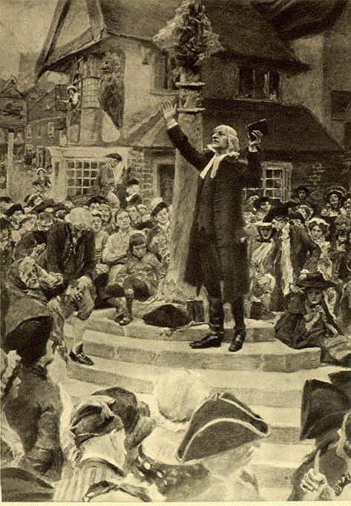

*'I am no longer my own but yours.  
Put me to what you will,  
rank me with whom you will;  
put me to doing,  
put me to suffering;  
let me be employed for you,  
or laid aside for you,  
exalted for you,  
or brought low for you;*  *let me be full,  
let me be empty,  
let me have all things,  
let me have nothing:  
I freely and wholeheartedly yield all things  
to your pleasure and disposal.  
And now, glorious and blessed God,  
Father, Son and Holy Spirit,  
you are mine and I am yours. So be it.  
And the covenant now made on earth, let it be ratified in heaven.*'

The early Methodists crossed out into their communities in fresh, bold and daringly innovative ways. Old, tired and increasingly ineffectual patterns of doing church and expressing faith were left behind as the Holy Spirit fuelled a radically bold Kingdom-centred revival. The way of the cross was embraced wholeheartedly and many were the sacrifices that were made to make inroads into the church averse society of the day. In many ways our Covenant Prayer offers us the theological rationale for how and why this was achieved.

The confidence that Jesus displayed as he undertook his ministry and subsequently made his way to the Cross was rooted and grounded in the Hebrew Scriptures. When St Paul says ‘there is nothing love cannot face’ (1 Cor.13) he is combining all that he believed about Jesus with the essential and timeless truths of Jewish identity and expressing clearly the heart of his personal faith. To take but three examples of where such trust is expressed and encouraged in the Old Testament:

*Commit your way to the LORD; trust in him, and he will act*. (Ps. 37:5)

*I hereby command you: Be strong and courageous; do not be frightened or dismayed, for the LORD your God is with you wherever you go*. (Joshua 1:9)

*But now thus says the LORD, he who created you, O Jacob, he who formed you, O Israel: Do not fear, for I have redeemed you; I have called you by name, you are mine.2When you pass through the waters, I will be with you; and through the rivers, they shall not overwhelm you; when you walk through fire you shall not be burned, and the flame shall not consume you*. (Isaiah 43:1)

This level of commitment and trust is always for a purpose. It is to enable God’s people to do God’s will and follow where God leads, as perhaps the prime example of what this means for us in practice demonstrates:

*Now the LORD said to Abram, “Go from your country and your kindred and your father’s house to the land that I will show you. I will make of you a great nation, and I will bless you, and make your name great, so that you will be a blessing. I will bless those who bless you, and the one who curses you I will curse; and in you all the families of the earth shall be blessed.” So Abram went, as the LORD had told him* (Genesis 12:1-4)

Such crossing out into the unknown is the archetypal experience of God’s people in the formative national narratives of Exodus and Exile. At the heart of God’s covenant with the people is God’s promise:

*Do not remember the former things, or consider the things of old. I am about to do a new thing; now it springs forth, do you not perceive it? I will make a way in the wilderness and rivers in the desert*(Isaiah 43:18-19)

All of these biblical truths are what the apostles and the early church grasped and owned for themselves. It is what fired up the early Methodists to achieve such spectacular feats for Jesus too.

‘Crossing Out’ is not only a biblical imperative, it is a spiritual necessity if we are to follow Jesus in our time and place.

Isaiah 42:1-9 encapsulates the essential dynamics of this process. It provides a wonderful template for us as we grapple with all that ‘Crossing Out’ implies for our Circuit and all that it will require from us as individuals. The way of the cross which Jesus walked was without doubt shaped by texts such as this one:

We are chosen and cherished by God and empowered to fulfil God’s Kingdom purposes

*Here is my servant, whom I uphold, my chosen, in whom my soul delights; I have put my spirit upon him; he will bring forth justice to the nations*.

As God loves us so we love others as those made in God’s image, bringing into being the justice for which God longs

*2He will not cry or lift up his voice, or make it heard in the street; 3a bruised reed he will not break, and a dimly burning wick he will not quench; he will faithfully bring forth justice.*

We do not give up but trust in the awesome loving presence of our Creator God

*4He will not grow faint or be crushed until he has established justice in the earth; and the coastlands wait for his teaching. 5Thus says God, the Lord, who created the heavens and stretched them out, who spread out the earth and what comes from it, who gives breath to the people upon it and spirit to those who walk in it:*

Crossing out, we are led by the hand and gifted to the world God loves so much to make God’s Kingdom apparent, transformative and inclusive.

*6I am the Lord, I have called you in righteousness, I have taken you by the hand and kept you; I have given you as a covenant to the people, a light to the nations, 7to open the eyes that are blind, to bring out the prisoners from the dungeon, from the prison those who sit in darkness. 8I am the Lord, that is my name; my glory I give to no other, nor my praise to idols. 9See, the former things have come to pass, and new things I now declare; before they spring forth, I tell you of them.*

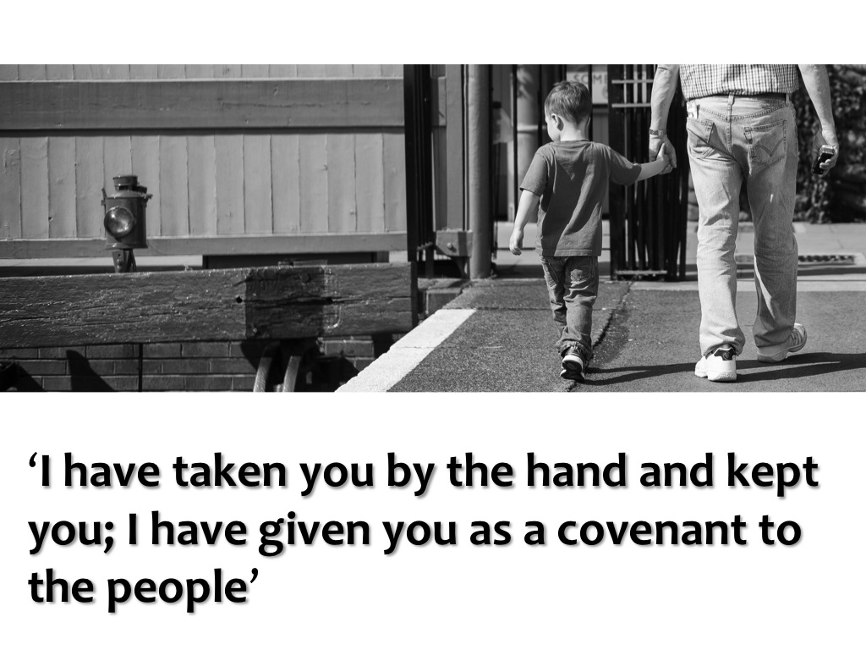

As Easter people living in a Good Friday world we know for ourselves that love can face up to anything. Therefore, as God once again takes us by the hand, we are confident and hopeful.

The process of ‘Crossing Out’ we are now embarking upon as a Circuit will be the making of us. As a piece of contemporary wisdom puts it: ‘*what a caterpillar calls the end, the Master calls a butterfly’*.

**THE GRACE OF GIVING**

“*Crossings Out*” is about the renewal and reshaping of our Circuit. It is about much more than addressing our finances but inevitably money has to be a part of our thoughts and considerations.

Our Circuit currently needs to raise about £400,000 a year from the Circuit Assessment in order to pay its existing staff, both ordained and lay, and to meet all the other costs and expenses which arise. This equates to approximately £400 for each and every member and, of course, each local church also needs to raise sufficient income in order to pay its own expenses of heating and lighting, property repairs and maintenance, insurance and so on.

However, nowhere in the Scriptures does it say that a Christian should give money to the Church only if the treasurer can produce financial statements to justify the **need** for giving. St Paul was quite clear in insisting that giving cannot be based on **needs**. He stated that stewardship is a matter of returning to God, regularly and sacrificially, a portion of the money and possessions we have – *simply because we believe.*

In the Church we often talk about money at the wrong time, in the wrong way and for the wrong reason. Usually we talk about it when there is a looming financial crisis and this is rarely the time when we do our best thinking and when we can take a calm and prayerful longer term view.

Often we view appeals for money as a lifebelt to keep the Church afloat or maybe as a tax which we are obliged to pay and then there is a risk that our money is given grudgingly and not freely.

It has been said that if the Church does not sort out its money it will end up focussing all its energies on money; if it doesn’t sort out its buildings it will end up focussing on buildings; but if it sorts out its money and buildings it can end up focussing on mission. That message would seem very pertinent to what we in Hull (Centre and West) Circuit are aiming to achieve.

If Jesus is to become real and live in us today, if we are to generate new disciples and fulfil our mission then stewardship needs to be a natural response to the grace and love of God and that includes responsible giving of money. Giving should be relative to income and according to means. Some will give £2 per week, others £20 or £50 per week.

Paul writing to the Corinthians tells us “*Remember this – a farmer who plants only a few seeds will get a small crop. But one who plants generously will get a generous crop. You must decide in your heart how much to give. And don’t give reluctantly or in response to pressure. For God loves a person who gives cheerfully. And God will generously provide all you need. Then you will always have everything you need and plenty left over to share with others*.” (2 Corinthians 9; 6-8)

**CIRCUIT TO CHURCH DISCUSSIONS NOVEMBER 2013- JANUARY 2014**

1. Tell us about the pressing issues that you face as a church?
2. How many new members have joined the church over the past five years?
3. What new initiatives in Mission have you started?
4. What impact have the above initiatives in Mission had and how are they bearing fruit?
5. Looking ahead to the next five years how secure is your church financially?
6. Thinking realistically, over the next five years and beyond is your future primarily as a centre of fellowship (offering love and care for a steadily declining number of people in the existing congregation, with regular traditional services) or as a centre of mission (actively implementing the Circuit’s Mission Policy by engaging with and meeting the needs of the wider community, making new disciples, offering a variety of worship experiences tailored to the missing generations etc)?
   1. What involvement did you have with the Circuit Mission Weekends, and which worship services were most popular with your congregation?
7. How will expectations need to change in a Circuit with fewer ministers, with all that this means for leadership, pastoral care, mission and the Circuit Plan?

(Presently we have 7 Presbyters and 1 Deacon; from September 2014 we will have 6 Presbyters and 1 Deacon, and from September 2015 we could reduce staffing to 5 Presbyters and 1 Deacon)

1. In order to cope with this reduction in ministerial staff would you be content to see some ministerial duties organised on a Circuit-wide team basis eg. Alpha courses, membership training classes, wedding and baptismal preparation etc.
2. We have to develop our strategic plans and our future objectives for the next five years. What does your church need from the circuit?
3. Bearing in mind what we have discussed, what recommendations and priorities would you give for the strategic use of:
   1. The Financial Resources of the Circuit
   2. The Human Resources of the Circuit (Ministers and Lay Employees)?

Macintosh HD:Users:revdwperry:Dropbox:circuit strategic review:hull central and west basic stats.pdf

**ANALYSIS AND INTERPRETATION**

In order to facilitate a ready grasp of the trends and issues which emerged from the consultations an attempt was made to record answers verbatim into a standard reporting framework. These original datasheets are given in the Appendix. This data represents the opinions and views that were expressed by the people chosen by the churches themselves to be present at the consultations as they answered the standard set of questions put to them. As such these responses offer a snapshot of the thinking of each church as it was presented to the Circuit Team. The Summary Data Table collates some of this information into a more accessible format, under three broad headings.

**The Connexional Statistics** given are those registered by our Circuit on the Statistics For Mission Website of the Methodist Church. It has to be said that these are not the most reliable of statistics, but for the purposes of this review comparisons between the latest figures for each church and those for 2008 / 2009 help us to focus on broad underlying trends. Given the wide variation in the sizes of our churches regarding membership and attendance there is little merit to be gained, however, in comparing percentages down the columns for these two variables.

**The Survey Responses** reflect the considered opinions expressed by the church representatives in answer to the first five questions. We have sought to be as fair and accurate as possible when recording the entries in this section of the Data Table. Subsequently a church may or may not agree collectively with certain aspects of what we were told and what is recorded, either in this section or in the full survey data, but that does not detract from the findings given here, as we are often dealing with subjective value judgements and not hard objective facts.

**The Key Questions** are ones which the CLT believes need to be asked as we consider the data as a whole from a strategic point of view. These simple questions help to focus our attention on important matters. The question “*is this a growing church*” is of course difficult to answer in many cases. For example, Fresh Expressions of Worship such as Messy Church do not easily translate into growth which sustains the life of the church as a whole and which replenishes its leadership, yet they are to be warmly welcomed as signs of engagement with the missing generations. This dilemma and other similar ones underline the fact that the honest answer to this particular question is often best given as “possibly”. Only one church receives an unequivocal ‘yes’, which of itself is revealing of where we find ourselves as a Circuit.

**PRESENTING ISSUES**

An analysis of the survey responses and the feedback from the consultation held at Willerby in February 2013 highlights at least three important clusters of concerns which the Circuit must collectively address:

Provision of Worship

Viability of Churches

Staffing

These important presenting issues, which were identified by the churches themselves during these conversations, together with the solutions that were suggested, are categorized below.

**PROVISION OF WORSHIP**

**PRESENTING ISSUES**

Resources spread too thinly - no consistency or continuity

Plan system outdated

**SOLUTIONS**

concentrate resources & reduce demand

Close some churches

Combine congregations

Not all churches would have a service every week

Put the churches together as one centre; use others as community centres

Plant new church where need is greater

Identify needs and start with a new building

Seek ecumenical solutions

Improve the product

Develop alternative forms of worship

Strive for excellence, especially in consistency and continuity of worship

Churches to develop a distinctive brand style

Provide help with provision of quality music within churches

Provide more family friendly worship

Rearrange delivery

Change times of services

Stagger times of services so ministers can take more than one service eg two in morning, one afternoon and two in evening

Deploy lay people more flexibly eg allow lay people to take communion

Have joint services

Have joint communion services

Let churches have a hand in selecting the preachers they want

Recruit more local preachers

Have more local arrangements

Circuit to arrange travel to combined services

**BARRIERS**

Congregations can’t / won’t travel much further afield to worship elsewhere

Reluctance to let go of evening services

Resistance to the old cluster system

Strain on staff of multi-service provision on Sundays

**VIABILITY OF CHURCHES**

**PRESENTING ISSUES**

Ministers cannot meet expectations of congregations (especially concerning overall involvement, leadership and pastoral care)

Buildings a drain

Missing generations and lack of succession put strain on ageing local leadership

Adequate resources of people and money are lacking in many of our churches

Many of our churches are declining and their future is in question

**SOLUTIONS**

concentrate resources & reduce demand

Reduce number of churches

Struggling churches to become classes of stronger ones / one church on several sites approach

Adopt a twin track Centre’s of Fellowship / Centre’s of Mission approach

Put Ministerial resources primarily into Centre’s of Mission (at 2 CM’s per presbyter)

Rearrange delivery

Care for Centre’s of Fellowship on a TLC basis, especially making use of Lay Pastors, with a Presbyter to lead the team

Put majority of available resources and effort into viable Centre’s of Mission

Organize at Circuit Level to provide key functions for local churches eg property, finance, safeguarding, administration

Avoid duplication of effort by providing team resourced Circuit programmes for Alpha, membership preparation etc

Stronger churches to assist weaker ones

Task Lay Employees to undertake key pieces of missional engagement for churches

**BARRIERS**

Congregations want their own Minister

Little agreement on where the priority should lie regarding numbers of Ordained and Lay Staff.

Resistance to provision at Circuit level which dilutes the importance of the local church

**STAFFING**

**PRESENTING ISSUES**

Cannot afford the staff we currently have and the Circuit says it wants

Presbyters overstretched keeping existing model of oversight going

Tension between mission and pastoral care

Frequent changes in pastoral charge destabilizing for those churches affected

**SOLUTIONS**

increase giving or reduce staffing

Encourage realistic giving

Raise profile of tithing, stewardship and targetted giving

Reduce presbyteral staffing

Make lay employees redundant

concentrate resources & reduce demand

Role of Presbyters to be focused upon leading centre’s of mission and the delivery of the Circuit Mission policy

Reframe churches expectations accordingly

Rearrange delivery

Staff Team to use gifts and charisms strategically

Recruit, train and authorize a team of Circuit Lay Pastors

Centre’s of Fellowship to be cared for by the team of CLP’s led by the Superintendent, such provision to be in partnership with Supernumeraries wherever possible

Develop and deploy lay gifts

**BARRIERS**

Expectations resistant to change

Consumerist view of the assessment leads to a church-centric culture of entitlement regarding staff input, rather than a strategic and missionally prioritised one

**HULL (CENTRE AND WEST) METHODIST CIRCUIT**

**STRATEGIC REVIEW REPORT – “CROSSINGS OUT”**

**QUESTIONS TO FACILITATE DISCUSSION AT LOCAL CHURCHES**

1. What level of support is there in your church for a major overhaul of the Circuit’s strategy and working methods as laid out in the report?

|  |  |  |  |  |
| --- | --- | --- | --- | --- |
| Almost 100% | Large majority | 50:50 | Minority | Almost zero |

*[please provide any relevant comments]*

1. Do you agree that the Circuit needs to prioritise its resources, both in terms of personnel and finance, in favour of pursuing its missional objectives as set out in the Mission Policy?
2. Do you agree with the principle of classifying churches as Centres of Mission (CM), Centres of Fellowship (CF)or Centres of Fellowship aspiring to become Centres of Mission (CFA) and do you agree with the classification of your own church (page 13 of report)? If not please explain why you disagree.

*[it is expected that as part of the process each church will be formally asked to declare itself a CM, CF or CFA]*

1. Do you understand and agree with the different levels of support which it is proposed will be provided to churches, depending on which classification they fall into?
2. Given the limited number of ordained staff the Circuit can deploy, does the proposal to form a team of Lay Pastors to care for Centres of Fellowship meet with your approval and support?
3. The report contains a section on “The Grace of Giving”. We are challenged as Christians to give freely to God but there is often little guidance given on the subject. Would your church be open to receiving literature or teaching on this fundamental aspect of our faith?
4. Given our limited resources of people and money we have too many places of worship to be able to deliver an effective Christian message. If we were able to concentrate our resources into fewer worship centres then we would free up people who are over-burdened by the responsibilities of looking after property, finance etc. Do you recognise this as an issue in your church and is it time for a serious discussion about the future of your church?
5. If, after prayerful consideration, your church council took the decision to “cease to meet” what would you want from the Circuit to ensure continued pastoral care and support for your members?
6. Is there anything which you feel the report has failed to address and do you have any constructive suggestions to make which you feel should be taken into consideration as part of the review?

*‘ we believe that we are called together by God to be Spirit-led, with a heart for Jesus and a passion for mission.’*

**The Methodist Church - Hull (Centre and West) Circuit**

**Registered Charity Number 1132962**

|  |  |
| --- | --- |
| Name of Church |  |

**Application from Church Council for designation as a Centre of Mission**

NB. All applications need to be approved by the Church Council

Each of the churches is invited to self-designate as either a Centre of Mission or a Centre of Fellowship. On the recommendation of their Church Councils, prospective Centres of Mission will need to apply to the CLT on the form below. Churches will need to provide substantive evidence of meeting three or more of the mission objectives specified in the Circuit Mission Policy:

a Making new disciples and growing in discipleship

b Establishing fresh expressions of church and church planting

c Initiatives in mission-shaped ministry

d Community focused social action

e Work with families, young people and children, and older people

f Reaching the missing generations

g Building community cohesion

*Note: These are faith-based missional objectives. Simply renting out church premises to groups, without a dimension of faith engagement, is not mission in the accepted sense*.

CLT will make recommendations on designation ratification to the Circuit Meeting.

Churches seeking designation as Centres of Fellowship are not required to complete the form but are asked to let the Secretary of the Circuit Meeting know (by letter or email)

**Please complete sections A - D**

with reference to the Guidance Notes

**A:**

Please list below three or more of the Circuit’s mission objectives given in a – g above that you currently meet

1.

2.

3.

4.

5.

6.

7.

**B:**

For each objective you have listed please provide a detailed description of the work being undertaken and explain how it meets the objective. It is essential that the information asked for in the Guidance Notes is provided.

**C:**

Please attach your Church Mission Policy Statement, highlighting the areas of the policy that are relevant to this application.

**D:**

Please also outline plans which your church is in the process of formulating to develop new missional activities in the future.

**Declaration** (to be signed by the Church Council Secretary)

I confirm that the above application has been approved by the Church Council at its meeting held on:

Date

Name

Signed

**When completed this form should be sent to the Circuit Meeting Secretary**

**Mr Don Granger, 3 Peaseholme, Hessle, HU13 0HY**

**E-mail –** [**don@granger1.karoo.co.uk**](mailto:don@granger1.karoo.co.uk)

**To arrive no later than Monday 17th November 2014**

**GUIDANCE NOTES**

**E:**

In order to assess whether the evidence provided is substantive and persuasive it is imperative that you describe your mission projects in as much detail as possible.

A qualitative approach alone will not suffice.

Quantitative data is essential and we ask for the following to be included for each mission initiative you submit:

1. How long the activity has been established
2. Number of leaders from the church
3. Number of leaders from outside the church
4. Numbers attending from within the life of the church
5. Numbers attending from outside the life of the church
6. The trend in these attendance figures since the initiative was established
7. The number of new disciples making a Christian commitment

This data will enable the CLT to judge the application on the basis of measurable outcomes.

**F:**

The deadline for the return of the completed forms is Monday 17th November 2014

**G:**

All such designations agreed by the Circuit Meeting are subject to an annual review

**THE METHODIST CHURCH - HULL (CENTRE AND WEST) CIRCUIT**

To:  Church Council Secretaries     21 June 2016

Dear Colleague

**REVIEW OF CENTRES OF MISSION**

In 2014 each church in the circuit was invited to apply for designation as either a Centre of Mission or a Centre of Fellowship. Prospective Centres of Mission were expected to provide substantive evidence of meeting three or more of the objectives set out in the Circuit Mission Policy:

a.  Making new disciples and growing in discipleship

b.  Establishing fresh expressions of church and church planting

c.  Initiatives in mission-shaped ministry

d.  Community focused social action

e.  Work with families, young people and children, and older people

f.  Reaching the missing generations

g.  Building community cohesion

Churches were also asked to provide outline plans which were being formulated to develop new missional activities in the future.

In the documentation for completion by churches it was made clear that once a designation had been agreed it would be subject to an annual review.  Churches are now asked to provide a statement in order to initiate this review.

Essentially, what is sought is the identification of developments in the last 18 months in furtherance of the Mission Policy objectives set out above. In addition, it would be helpful if churches could identify any significant changes to the work being undertaken at the time of the earlier review (including, where relevant, any discontinuation of activities). There may also be plans under active consideration for new missional activities which have not yet come to fruition.

As with the original review, quantitative data is needed where possible, although it is appreciated that new developments can take some time to become established and may still be growing.

A lengthy statement is not required and straight repetition of matters cited in the original documentation should be avoided.

In summary, each church is invited to reflect on ‘where we were’, ‘where we are’, ‘where we will be’.

This note is intended for churches which have been designated as Centres of Mission although it is being sent to all circuit churches in case a Centre of Fellowship feels the need to seek reconsideration of its categorisation. Responses will be considered by the Circuit Leadership Team and reported to the Circuit Meeting.

After approval by the Church Council please send the statement for your church to the Circuit Meeting Secretary at the address shown above, by 30 October 2016.

Yours sincerely

DON GRANGER

Circuit Meeting Secretar